A URL Shortener

Submitted by

TAN XINGZHI
3036532736
B. Eng. (Polyu)

A dissertation submitted in partial fulfilment of the requirements for the degree of Master of Science in Engineering
(Electrical and Electronic Engineering)

At the
Department of Electrical and Computer Engineering
The University of Hong Kong

In
May 2026

ABSTRACT

The abstract should be suitable for direct inclusion in abstracting services as a self-contained article. The length of the abstract should not exceed 1 page. Do not include figure numbers, table numbers, references or displayed mathematical expressions. Provide the abstract word count.

Abstract Word Count: XXX

DECLARATION

I declare that this dissertation represents my own work, except where due acknowledgement is made, and that it has not been previously included in a thesis, dissertation or report submitted to this University or to any other institution for a degree, diploma or other qualifications

Signed_______________________________________________________

ACKNOWLEDGEMENT

I would like to express my sincere gratitude to all those who contributed to the completion of this thesis.

First and foremost, I would like to thank xxxxxxxxxxxxx

Finally, I am deeply grateful to my family for their constant love, patience, and belief in me. This thesis would not have been possible without their unwavering support.

Thank you to everyone who contributed directly or indirectly to this work.

[Your Name]
[Date]

目录
ABSTRACT 2
DECLARATION 3
ACKNOWLEDGEMENT 4
CHAPTER 1 INTRODUCTION 7
1.1 Research Background and Motivation 7
1.2 Project goals and innovations 9
1.3 Report Structure 10
CHAPTER 2 LITERATURE REVIEW 11
2.1 Development and Evolution of URL Shortening Technology 11
2.2 Research on Short Link Security Threats 14
2.3 Analysis of Related Systems and Platforms 16
2.4 Overview of Key Technologies 18
Chapter 3 PROPOSED METHODOLOGY 19
3.1 System Architecture Design 19
3.1.1 Presentation Layer 19
3.1.2 Business Logic Layer 21
3.1.3 Data Persistence Layer 22
3.1.4 Request Processing Flow 23
3.2 Core Module Design 24
3.2.1 Short Code Generation Algorithm 24
3.2.2 User Authentication System 26
3.2.3 Batch shortening function 27
3.2.4 Click Analysis Engine 28
3.2.5 QR Code Generation Module 29
3.3 Database Design 30
3.3.1 users table 30
3.3.2 url_mappings table 31
3.3.3 Clicks Table 31
3.4 Trilingual Internationalization Engine 32
3.5 Security Mechanism Design 33
Chapter 3 EXPERIMENTAL RESLUTS 35
4.1 Functional Verification 35
4.1.1 Basic URL Shortening Functionality 36
4.1.2 Password protection function 40
4.1.3 Link Expiration Management 41
4.1.4 Batch shortening function 42
4.1.5 Multi-user authentication and permissions 43
4.1.6 Trilingual Internationalization 45
4.2 Performance Evaluation 47
4.2.1 Core Interface Response Time 47
4.2.2 Short code collision probability analysis 48
4.2.3 System Resource Consumption 48
4.3 System Deployment and Maintenance 49
Chapter 5 CONCLUSION 50
5.1 Work Summary 50
5.2 Existing shortcomings and limitations 52
5.3 Future Outlook 53
5.4 Conclusion 54
References 56

CHAPTER 1 INTRODUCTION

1.1 Research Background and Motivation
Internet access is now an integral part of people's lives; mobile phones and computers are ubiquitous. We obtain information daily through various links—news from friends, attachments in work emails, QR codes at restaurant entrances, shared cards in chat software—all ultimately linked to a URL. It's fair to say that the URL has become the basic unit of information transmission.
However, the problem is that URLs are getting increasingly long. A typical e-commerce link or social media sharing link often has 200 to 500 characters. This length is due to the excessive amount of information crammed in—query parameters, session IDs, ad tracking codes, content hashes, various redirects, and so on. While these elements are useful to the website's backend, they are merely redundant information for the user. Such long links cause many problems in practical use: text messages and tweets have character limits, making it impossible to fit them all; no one wants to type them out word by word on posters; it's even less likely to be remembered verbally; and they don't look professional or aesthetically pleasing.
URL shortening services aim to solve this problem. The principle is actually quite simple: the user submits a long URL to the server, and the server returns a very short new link. The correspondence between this shortened link and the original link is stored in a database. When someone clicks on this shortened link, the server finds the original link and then automatically redirects the browser to it. In this way, a link of a few hundred characters becomes a short form like "bit.ly/3xK9pQ".

The market demand for this service is real and large. Antoniades et al. [1] published a paper at the 2011 WWW conference, finding that the use of shortened links was growing by about 10% per month. They conducted large-scale data crawling and found that the popularity ranking of websites linked by shortened links was very different from the results of traditional ranking services such as Alexa. They called this phenomenon "alternative web", meaning that shortened links reflect a set of user behavior patterns that are completely different from traditional statistics.
However, shortened links also bring security problems. Neumann et al. [2] published an influential paper in 2011, listing various security risks of shortened links. For example, shortened links can be used to bypass SSL encryption protection; malicious service providers can track user click behavior; attackers can discover links that should not be made public by guessing the short code. More importantly, they found a large number of shortened links in over 7 million spam emails, indicating the severity of the problem.
Based on this background, I created a project called LinkSnap. It's a multi-user URL shortening service system that supports three languages. In its design, I referenced academic research on shortened link security, reviewed the functional designs of mature products on the market, and incorporated the unique features of Hong Kong's Mandarin, English, and Cantonese languages. The goal was to find a balance between functional completeness, user experience, and security.

1.2 Project goals and innovations
This project aims to design and implement a fully functional, secure, reliable, and user-friendly URL shortening service system from scratch. Core objectives include:
(1) A complete functional loop. Implementing a full suite of functions including URL shortening (single and batch), custom short codes, link expiration management, password-protected access, automatic QR code generation, tag classification and search filtering, and click analysis reports.
(2) A multi-user collaborative system. Building a complete user registration, login, and password reset (SMTP email support) authentication system, as well as a role-based access control mechanism. Users can only manage links they create, while administrators (admin account) can perform global monitoring and management.
(3) A trilingual internationalization engine. A self-developed i18n module supports seamless switching between Simplified Chinese (zh-CN), English (en), and Cantonese/Traditional Chinese (zh-HK). Language preferences are persisted to cookies, covering over 230 translation entries. This is relatively rare in similar open-source projects.
(4) A multi-dimensional data analysis dashboard. Integrated with Chart.js for interactive data visualization, including click trend line charts, source distribution pie charts, browser and operating system bar charts, and country/region ranking charts. Providing marketers and content creators with in-depth data insights.
(5) Production-grade deployment capabilities. Implements a dual database adapter for SQLite/PostgreSQL—the development environment automatically uses SQLite, while the production environment switches to PostgreSQL via environment variables. A built-in automatic database migration mechanism supports forward compatibility upgrades with zero downtime. Works with the Gunicorn multi-process WSGI server for concurrent processing capabilities.
The innovations of this project can be summarized in three aspects: First, the design and implementation of the trilingual internationalization engine, its multi-level priority detection mechanism (URL parameters > Session > Cookie > Accept-Language request header) and formatted parameter support are relatively rare practices in this field; Second, it integrates multiple functional modules such as short link service, user system, analysis engine, and scheduled tasks in a single Flask monolithic application, demonstrating good architectural design capabilities; Third, it implements multi-layer protection such as parameterized query, password salting hash, permission verification, and redirection verification at the security engineering level, directly responding to the short link security threats revealed by the academic community [2][6][7].

1.3 Report Structure
The subsequent chapters of this report are organized as follows: Chapter 2 is a literature review, outlining the development of short link technology, summarizing the research achievements in this field, analyzing the functional characteristics and limitations of mainstream platforms, and introducing the key technologies involved in this project. Chapter 3 elaborates on LinkSnap's system architecture, core module design (including short code generation algorithm, user authentication, batch shortening, click analysis engine, etc.), database design scheme, implementation details of the three-language i18n engine, and multi-layered security mechanisms. Chapter 4 conducts a comprehensive test and analysis of the system from three dimensions: functional verification, performance evaluation, and system deployment. Chapter 5 summarizes the project results, points out current shortcomings, and proposes future improvement directions.

CHAPTER 2 LITERATURE REVIEW

2.1 Development and Evolution of URL Shortening Technology
Shortened links originated around 2002. That year, Kevin Gilbertson created a website called TinyURL, the first widely known shortened link service on the internet. Its approach was incredibly simple: the user provided a long URL, and the system returned a shortened link like "tinyurl.com/xxxxx," which, when clicked, resulted in a 301 permanent redirect. This "store-map-then-redirect" model remains the foundation of all shortened link services today.
The real surge in popularity of shortened links was related to the rise of social media. After Twitter launched in 2006, each tweet was limited to 140 characters, making long links insufficient. At this time, Bitly (originally bit.ly), founded in 2008, quickly grew into a major player. Bitly's success wasn't just about shortening links; more importantly, it transformed short links into a marketing analytics tool—providing data on click-through rates, referral channels, and geographic location. By 2011, Bitly had secured $15 million in funding, transforming from a tool-based product into a platform.
The academic community's attention to short links also began around the same time. Antoniades et al. [1] published a paper titled "we.b: The Web of Short URLs" at the 2011 WWW conference, which is the pioneering work in this field. They did two things: first, they crawled various short link services on a large scale, and second, they crawled Twitter news feeds. Then, for the first time, they systematically answered several questions: What content do short links point to? How are they published and spread? How long do they remain active? They found several interesting phenomena: the difference between popular websites and Alexa rankings in short links is large; the collection of popular websites is relatively stable, but the popularity window of a single short link is very short; about half of the short links are still usable three months after creation, and are not one-off; in addition, the redirection process of short links brings additional performance overhead. This paper has been cited more than 148 times, and many subsequent studies are based on it. Maggi et al. [3] conducted a large-scale measurement study in 2013. They monitored 622 short link services and collected nearly 25 million short URLs over two years. The results showed that although the proportion of malicious short links was not large, the trend was upward. More importantly, they found that the anti-abuse measures of mainstream short link services were ineffective and easily bypassed. This gave me a very important reminder: the security of short link systems cannot rely solely on post-event detection; it must be considered from the architectural level. Gupta et al. [4] published a paper at the 2014 eCrime conference specifically studying the problem of spam link detection in Bitly. They obtained approximately 760,000 short links marked as suspicious from Bitly and found that Bitly allowed users to shorten malicious links without performing any pre-checks when the links were created. Although some could be detected afterward, there was a time lag between creation and detection. Their proposed semi-supervised classification method provides a feasible approach for short link spam detection. Le Page et al. [5] conducted an interesting comparative study in 2018. They used short link click analysis data to compare the lifecycle of phishing attacks and malware attacks. They found that phishing attacks peaked about four hours before being reported, with high click-through rates but short durations of activity; malware attacks, on the other hand, began to be active about four days earlier, with low click-through rates but long durations—more than half of malware attacks remained active for several years. This indicates that different types of attacks require different countermeasures.

2.2 Research on Short Link Security Threats
The security of short links is the problem that always been a focus by academic attention. Neumann et al. [2] published one of the most well-known security reviews in this field in 2011. This paper systematically categorizes and analyzes in detail these six types of security and privacy risks:
(1) Malicious Redirection. Malicious or compromised short link service providers may redirect users to websites containing malware or phishing pages. Since short links themselves do not contain any hints about the target URL, users cannot determine the security of the link before clicking it—Zhang et al. [6] described this feature as a "native security flaw" of short links in their 2024 study.
(2) User Tracking & Privacy Leakage. Short link service providers can track users' click behavior through cookies, IP addresses, and browser fingerprints. In academic peer review scenarios, this tracking capability is more likely to jeopardize the anonymity of blind review—when reviewers click on short links in the manuscript, their IP address, geographical location, device information, etc., may expose their identity information. (3) Short Code Enumeration Attack. Attackers can discover secret URLs that should not be made public by exhaustively exploring the short code space (e.g., trying all possible 6-bit Base62 encoding combinations in sequence). Neumann et al. [2] conducted enumeration experiments on the 10 most popular short link services on Twitter and found that many service providers did not take effective anti-enumeration measures.
(4) URL Leakage to Search Engines. Some short link services may inadvertently expose short URLs to search engine crawlers, resulting in links that should only be shared in a small circle being publicly indexed.
(5) SSL/TLS Degradation Attack. This is a new attack scenario proposed in this paper: attackers can construct HTTP short links pointing to HTTPS sites and strip the SSL encryption layer at the man-in-the-middle position.
(6) Spam Abuse. This study analyzed over 7 million spam emails since 2003 and found that short links are widely used in spam, and spammers use various obfuscation methods to hide the existence of short links.
Research in this area has continued in recent years. Odgerel et al. [7] developed a random forest-based classifier in 2025 that can automatically identify which domains are short link services. The accuracy rate reached 98.4%. They also found that the actual number of short link services is much higher than publicly known. The median processing time for malicious short links is about 48 hours. Fukushi et al. [8] studied the special risks of ad-driven short link services. They found that such services generate an average of 86.5 requests to malicious domains per short URL. More worryingly, even if users only click the correct navigation button, they may unknowingly communicate with malicious domains. Chinese scholars Zhang et al. [6] proposed a short link security framework from both server-side and client-side perspectives in a paper published at the IEEE ICETCI conference in 2024. This framework includes malicious link detection tools, Web Application Firewall (WAF) deployment, and optimized design of short link service algorithms. This work provides direct guidance for the practice of short link security defense.

2.3 Analysis of Related Systems and Platforms
To clarify LinkSnap's positioning and differentiated advantages, this section will compare and analyze the major URL shortening platforms currently on the market.
Platform | Free Usage | Custom short code | Click analyse | Multilingual | Open source | Self-deployment
Bitly | Limited | Paid | Advanced | English only | No | No
TinyURL | Yes | Yes | Basic | English only | No | No
Rebrandly | Limited | Yes | Advanced | English only | No | No
YOURLS | Yes | Yes | Plugin-based | Community translated | Yes | Yes
Shlink | Yes | Yes | Basic | Partial | Yes | Yes
LinkSnap | Yes | Yes | Advanced | Trilingual | Yes | Yes
Table 1 Comparison of features of mainstream URL shortening platforms
As the table shows, commercial platforms (Bitly, Rebrandly) offer limited functionality in their free tiers, with enterprise-level features such as advanced analytics and custom domains requiring paid subscriptions. Bitly dominates the market due to its brand effect and first-mover advantage, but its free tier doesn't even support custom short codes.
In the open-source realm, YOURLS (Your Own URL Shortener) is the oldest and most actively community-driven PHP/MySQL shorting system. YOURLS has proven the feasibility of building your own shorting service and boasts a scalable plugin system, but its technology stack is relatively traditional (PHP), its front-end interface is relatively basic, and it lacks native multi-language support and modern interactive data analysis dashboards. Shlink is a newer open-source shorting system (based on PHP/Symfony) that provides a REST API interface, making it suitable for use as a back-end service, but its web front-end and management functions are relatively streamlined.
LinkSnap's design fully incorporates the advantages of the aforementioned platforms while addressing their respective shortcomings: it adopts the Python/Flask technology stack for higher development efficiency; it features a complete WYSIWYG trilingual interface; it has built an interactive analysis dashboard based on Chart.js; it has implemented a user permission system and management panel; and it supports a seamless database upgrade path from SQLite to PostgreSQL.

2.4 Overview of Key Technologies
LinkSnap's technology choices follow the principles of "simplicity, modernity, and maintainability." The key technology components are outlined below:
Flask Web Framework. Flask is a lightweight Python WSGI Web framework developed by Armin Ronacher. It is known for its "microkernel plus extension" concept, which Miguel Grinberg systematically described in his authoritative book "Flask Web Development" [9]. Flask's kernel is extremely streamlined—route matching, request-response loop, Jinja2 template engine—while advanced features such as database ORM, form validation, and user authentication are integrated on demand through extensions. This architecture is well-suited for monolithic web applications of the graduation project scale: it maintains both code readability and controllability while providing sufficient space for necessary extensions. Chart.js Data Visualization. Chart.js is an open-source JavaScript charting library based on HTML5 Canvas, known for its zero dependencies, responsive design, and concise API. It natively supports eight chart types, including line charts, bar charts, donut charts, and radar charts. In LinkSnap, it is used to build five categories of interactive charts: click trends, source analysis, browser distribution, operating system distribution, and geographic distribution. Chart.js's animated rendering and hover tooltips greatly enhance the interactive experience of the analytics dashboard.
QR Code Generation. qrcode is one of the most popular QR code generation libraries in the Python ecosystem, based on the PIL/Pillow image processing library. It supports all features of the QR code standard—version number, error correction level (L/M/Q/H) and encoding mode (numeric/alphanumeric/byte/Chinese characters)—and can generate QR code images compliant with the ISO/IEC 18004 standard. In LinkSnap, each short link automatically generates a corresponding QR code upon creation and stores it as a PNG image file, providing a convenient entry point for offline dissemination of links (e.g., billboards, business cards, packaging, etc.).
IP Geolocation. The system uses the free IP geolocation API provided by ip-api.com, which maps IPv4/IPv6 addresses to three levels of geolocation information (country/region and city) without registration or API keys. The free version of this API is limited to 45 requests per minute, suitable for small to medium-sized deployments.

Chapter 3 PROPOSED METHODOLOGY

3.1 System Architecture Design
LinkSnap is a monolithic application based on Flask, but I divided it into three layers in my design: presentation layer, business logic layer, and data persistence layer. This layering approach is based on the REST architecture style proposed by Fielding [10] in his doctoral dissertation. The core of this architecture is "separation of concerns", where each layer manages its own business and does not interfere with each other.

3.1.1 Presentation Layer
The presentation layer consists of 17 Jinja2 template files and static resources located in the `static/` directory. The template engine is responsible for rendering the corresponding UI text based on the language context of the current request (stored in Flask's `g` object). Unlike mainstream SPA (Single Page Application) architectures, LinkSnap chooses a server-side template rendering solution primarily because: First, most pages of the short link service (homepage, dashboard, statistics page) need to retrieve data from the server (link list, statistics, etc.), and server-side rendering avoids additional API request round trips; second, the short link service has lower SEO (Search Engine Optimization) requirements, thus reducing the demands of the SPA solution on server-side rendering; finally, the template rendering solution significantly reduces the front-end complexity of the project, allowing developers to focus on business logic.
At the CSS level, the project builds a complete design system based on design tokens. All visual properties—color, font size, spacing, rounded corners, shadows, and transition animations—are defined using custom CSS properties/variables in the `:root` pseudo-class, forming a visual language with a "warm-toned editing style." The system natively supports dark mode—flicker-free theme switching can be achieved by overriding the CSS variable under the `[data-theme="dark"]` selector.
The front-end JavaScript is entirely implemented natively, without relying on any front-end frameworks. Interactive charts are rendered using Chart.js 4.4, and features such as modal dialogs, Toast notifications, language switching, and batch link recognition can all be implemented using native JS. This approach ensures the project's lightweight nature; it requires no npm/webpack build, and all code is immediately usable, making it a reasonable and practical choice for small graduation project projects.

3.1.2 Business Logic Layer
The business logic layer is the core of the entire system, consisting of Flask routing functions and utility functions. It mainly includes the following modules:
(1) URL shortening and short code generation module. This module handles the two core routes /shorten and /batch_shorten, responsible for long URL verification, short code generation and conflict detection, custom short code format validation and reserved word filtering, expiration time calculation, data writing to the database, and QR code generation. This module is the most complex part of the entire system, with multiple layers of verification at each step.
(2) User authentication and authorization module. This module handles routes related to registration, login, logout, and password reset, using the @login_required custom decorator to uniformly control access permissions. Passwords are salted and hashed using the Werkzeug security library, and password reset is implemented using a UUID v4 one-time token.
(3) Link management module. This module handles operations such as dashboard pagination search and filtering display, link editing, tag management, expiration extension, link deletion, and password viewing. All operations verify whether the user is the owner or administrator of the link before execution. (4) Click Analysis and Statistics Module. Handles redirection and statistics pages, including real-time click records (IP, User-Agent, Referer, geographic location), click count updates, and multi-dimensional aggregated statistical analysis.
(5) Scheduled Task Module. Two Cron endpoints: one for sending due date reminder emails, and the other for cleaning up expired links, triggered periodically by an external scheduled task scheduler.
(6) Management Panel Module. A dedicated /admin route for administrators, providing views such as system overview, user management, and link management.

3.1.3 Data Persistence Layer
LinkSnap achieves transparent switching between SQLite and PostgreSQL database backends through a unified database connection factory (the `get_db_connection()` function). This function determines the database driver to use by checking the existence of the `DATABASE_URL` environment variable. In PostgreSQL mode, the connection uses a `DictCursor` cursor factory (`psycopg2.extras.DictCursor`), ensuring that the row objects it returns are consistent with SQLite's `Row` factory in terms of access interface—regardless of the underlying database, the way the upper-level Python code processes query results is completely consistent.
The database initialization module (`init_db()`) executes automatically every time the application starts. This module uses the `CREATE TABLE IF NOT EXISTS` statement to ensure the creation of the core table structure. Furthermore, it uses the `column_exists()` helper function to check each field of each table one by one and performs an `ALTER TABLE ADD COLUMN` operation on missing columns. This incremental migration strategy ensures that the old version of the database files can still be correctly identified and used after the system is upgraded, avoiding the over-engineering problem of traditional Django/Alembic migration solutions in small projects.

3.1.4 Request Processing Flow
Taking URL shortening requests as an example, the complete processing flow is as follows: (1) The user enters a long link, selects the validity period, and optionally sets a custom short code and access password in the form on the homepage; (2) After the front-end JavaScript performs basic client-side validation, the form is submitted to the /shorten route via POST; (3) The @login_required decorator first verifies the user's login status in the Session, and unlogged users are redirected to the login page; (4) The routing function performs format validation on the long URL (non-empty check, protocol completion, etc.); (5) If the user specifies a custom short code, the complete six validation rules are executed—length, character set, hyphen position, consecutive hyphens, reserved word check, and database uniqueness check; otherwise, the random short code generation function is called and retried as needed; (6) The expires_at timestamp is calculated based on the expiry parameter and the EXPIRY_OPTIONS mapping dictionary; (7) The data is written to the url_mappings table using parameterized SQL INSERT; (8) The qrcode library is called to generate a QR code image and save it to static/qrcodes/<short_code>.png; (9) Render the success page (success.html), displaying the short link, a comparison of the original link, a QR code image, and a social sharing button.
The redirection process is similar to the one described above: When a user accesses a shortened link, the system checks in sequence whether the shortened code exists, whether it has expired, and whether it is password protected. If all checks pass, the click count is updated, client information (IP/UA/Referer) is extracted, the geolocation is queried, the click record is inserted, and finally, an HTTP 302 temporary redirect is returned. IP extraction prioritizes the X-Forwarded-For header (for compatibility with reverse proxy deployments), and if the geolocation query fails, the relevant fields are left blank, which does not affect the redirection.

3.2 Core Module Design

3.2.1 Short Code Generation Algorithm
Short code generation is one of the most critical technical decisions in URL shortening systems. The available options include:
Option A: Auto-incrementing ID + Base62 encoding. Use the integer value of the database's auto-incrementing primary key or a centralized counter, and convert it to a short code using Base62. Advantages: Absolutely no collisions, and the short code length is controllable. Disadvantages: Requires a global counter (which can become a bottleneck in a distributed environment), and the short code can be guessed—attackers can guess other users' links by enumerating neighboring IDs.
Option B: Hash truncation. Calculate the MD5/SHA-1/SHA-256 hash value for long URLs, and convert the first few characters to Base62 as the short code. Advantages: The same URL will always generate the same short code, eliminating duplicates. Disadvantages: Different URLs may collide, requiring salting to resolve this, increasing complexity.
Option C: Random string generation. Randomly select characters of a specified length from 62 alphanumeric characters to form the short code, and then check the database for uniqueness. Advantages: The short code is unpredictable, simple to implement, and does not require centralized coordination. Disadvantages: Collisions are theoretical
LinkSnap chose solution C. The specific implementation uses Python's `secrets` module to generate 6-digit short codes. The character set contains 62 alphanumeric characters, resulting in a total combination space of 62^6 ≈ 5.68 × 10^10, approximately 56.8 billion. Based on the birthday paradox, when the system stores 100,000 short codes, the collision probability is only about 8.8 × 10^-5. Automatic retries are performed upon collision, up to a maximum of 10 times.
For user-defined shortcodes, the system enforces strict six-layer validation rules: (a) Length must be 3 to 20 characters; (b) Only letters (a-zA-Z), numbers (0-9), underscores (_), and hyphens (-) are allowed; (c) Hyphens are not allowed at the beginning or end; (d) Consecutive hyphens (--) are not allowed; (e) It cannot be any of the 18 reserved words (admin, api, login, register, dashboard, shorten, r, static, etc.); (f) It cannot conflict with shortcodes already existing in the database. These rules ensure user freedom in naming while minimizing routing conflicts and format ambiguities caused by shortcodes.

3.2.2 User Authentication System
The user authentication system uses the Flask Session mechanism, storing session information using server-signed cookies. During user registration, passwords are salted and hashed using Werkzeug's `generate_password_hash()` function, defaulting to the scrypt algorithm (supported by Python 3.8+). Compared to PBKDF2 and bcrypt, scrypt is more effective at resisting brute-force and parallel attacks, making it a better choice. Login verification supports either username or email address, using the `check_password_hash()` function to compare the two passwords.
The password reset function uses a UUID v4 token-based process: after a user submits their registration email, the system generates a random UUID token and stores it in the `reset_token` field of the `users` table, setting `reset_token_expiry` to the current time plus one hour. The reset link is formatted as `/reset-password/<token>`. The system employs a dual-mode email sending strategy: when environment variables such as SMTP_HOST are configured, it sends formatted HTML reset emails via the SMTP protocol (using Python's smtplib and MIMEMultipart libraries); when SMTP is not configured, it automatically switches to "demo mode," displaying the reset link directly on the page. This dual-mode design ensures system availability in different network environments, such as campus networks and personal development machines.

3.2.3 Batch shortening function
Batch shortening is a particularly useful feature of LinkSnap. This feature is ideal for operations personnel, self-media creators, and marketing professionals to process multiple links at once. It allows for the import of multiple URLs in batches, the configuration of custom short codes and access passwords for each link individually, and the generation of shortened links in bulk. This efficiently facilitates the organization and distribution of promotional materials and resource links, avoiding the repetitive operation of creating links one by one, and significantly improving link management efficiency. After switching to the "Batch" tab, users paste multiple URLs (one per line) into the text box and click the "Recognize Links" button to trigger a front-end JS function. This function uses regular expressions to extract all valid links, removes duplicates, and displays them to the user in an editable table format. Users can set custom short codes and access passwords for each link individually.
Upon submission, the front-end assembles all URL entries in the table into a JSON array and submits it to the `/batch_shorten` endpoint via the `fetch()` API using the POST method. The back-end processes each link individually, reusing the core logic of single-link shortening, and collecting the success and failure results separately. Finally, it returns a JSON response containing the processing results for each link. The front end displays results in a card format—successful attempts are shown in green cards with a short link and a copy button; failures are shown in red cards with an error message. The top also aggregates and displays the number of successes and failures. The entire functionality is implemented using front-end JavaScript, without relying on any third-party libraries.

3.2.4 Click Analysis Engine
The click analytics engine is the core of LinkSnap's data insight capabilities. The `get_click_analytics()` public function is the entry point for the analytics engine. It performs multi-dimensional aggregation on the data in the `clicks` table, returning the following dimensions to the template rendering engine:
Basic Metrics: These include total clicks, unique visitors (deduplicated by IP), clicks today, first click time, and most recent click time. These five metrics form the basic profile of link propagation effectiveness.
Daily Click Trend: Click records from the past 30 days are aggregated by date using a `GROUP BY` clause to generate time-series data. The front-end uses `Chart.js` to render line charts, with Tensor 0.3 Bezier curve smoothing and semi-transparent fill areas. Dates without clicks are automatically filled with zeros to ensure chart continuity.
Referer Analysis: The Referer field is aggregated by domain name, and a Chart.js Doughnut Chart is used to display the traffic source distribution. Direct access (Referer is an empty string or NULL) is uniformly labeled "Direct Access". A maximum of the top 10 source domains are displayed; the rest are grouped into the "Other" category. Doughnut charts are visually more modern and easier to compare the size of different parts compared to pie charts.
Device and Browser Analysis: The parse_user_agent() function identifies six major browsers (Chrome, Firefox, Safari, Edge, Opera, Internet Explorer) and five major operating systems (Windows, macOS, Linux, Android, iOS) through string matching. A horizontal bar chart is used to display the distribution—the horizontal direction is better suited for displaying dimensions with longer category names.
Geographic Distribution: The country, region, and city information corresponding to each unique IP address is queried using the ip-api.com API. The aggregated data is displayed as a bar chart ranking the top 10 countries/regions by click volume. The system automatically handles API failures or rate limiting—if a query fails for an IP address, its country/region/city fields are left blank, ensuring no impact on records from other IP addresses. This API is completely free, requires no API key, and is suitable for small to medium-sized traffic volumes with a limit of 45 requests per minute.

3.2.5 QR Code Generation Module
The QR code generation uses the Python qrcode library (based on Pillow). After each shortened link is successfully created, the system automatically generates a QR Code object and saves it as a PNG file. The generation parameters are configured as follows: automatic version number selection, error correction level M (approximately 15% error tolerance), image size 10, and border width (4 modules).
The QR code generation process is decoupled from the main shortening process—even if QR code generation fails (e.g., due to insufficient disk space or permission issues), the shortening operation itself will succeed. Failed QR codes will display a "QR code generation failed" message on the page, and the system will log a WARNING level message.

3.3 Database Design
LinkSnap uses a relational database design, which three core tables maintain data integrity through foreign key constraints. The ER diagram can be described as: users (1) —< (N) url_mappings (1) —< (N) clicks.

3.3.1 users table
The `users` table stores user account information. Core fields include: an auto-incrementing primary key `id`, a unique `username` (maximum 100 characters), a unique `email` (maximum 255 characters), a salted hash of `password_hash` (255 characters), the registration time `created_at`, and the `reset_token` (UUID v4) and `reset_token_expiry` fields required for password reset.
CREATE TABLE users (
id SERIAL PRIMARY KEY,
username VARCHAR(100) NOT NULL UNIQUE,
email VARCHAR(255) NOT NULL UNIQUE,
password_hash VARCHAR(255) NOT NULL,
created_at TIMESTAMP DEFAULT CURRENT_TIMESTAMP,
reset_token VARCHAR(36),
reset_token_expiry TIMESTAMP
);

3.3.2 url_mappings table
`url_mappings` is the core business table of the system, storing complete metadata for each short link. Its field design covers all dimensions of link management requirements—identifier (id, short_code), content (long_url uses the TEXT type to accommodate very long URLs), attributes (is_custom distinguishes between system-generated and user-defined URLs), time (created_at, updated_at, expires_at support expiration management), count (click_count), attribution (user_id, a foreign key related to the users table), security (password_hash stores the Base64 encoded access password), category (tag used for search filtering), and maintenance (reminder_sent indicates whether an expiration reminder email has been sent).
CREATE TABLE url_mappings (
id SERIAL PRIMARY KEY,
long_url TEXT NOT NULL,
short_code VARCHAR(50) NOT NULL UNIQUE,
is_custom BOOLEAN DEFAULT FALSE,
created_at TIMESTAMP DEFAULT CURRENT_TIMESTAMP,
click_count INTEGER DEFAULT 0,
user_id INTEGER REFERENCES users(id)
ON DELETE SET NULL,
expires_at TIMESTAMP,
password_hash VARCHAR(255),
tag VARCHAR(50),
updated_at TIMESTAMP,
reminder_sent INTEGER DEFAULT 0
);

3.3.3 Clicks Table
The `clicks` table records each short link access event in append-only log mode. The `short_code` foreign key references the `url_mappings` table and has an ON DELETE CASCADE policy—when a link is deleted, all its click records are automatically cleaned up to maintain data consistency. `ip_address` uses the VARCHAR(45) type to support IPv6 addresses (maximum 45 characters). `user_agent` and `referer` use the TEXT type to accommodate potentially very long browser identification strings and source URLs. Geolocation-related fields (country, region, city) are nullable to accommodate IP geolocation API queries that fail.
CREATE TABLE clicks (
id SERIAL PRIMARY KEY,
short_code VARCHAR(50) NOT NULL
REFERENCES url_mappings(short_code)
ON DELETE CASCADE,
ip_address VARCHAR(45),
user_agent TEXT,
accessed_at TIMESTAMP DEFAULT
CURRENT_TIMESTAMP,
referer TEXT,
country VARCHAR(100),
region VARCHAR(100),
city VARCHAR(100)
);

3.4 Trilingual Internationalization Engine
LinkSnap's internationalization engine is a highlight of the system. It embodies the linguistic and cultural characteristics of Hong Kong, where Mandarin, English, and Cantonese are intertwined. This engine is implemented through an independent Python module, i18n.py, and is deeply integrated with the Flask framework. It completes the translation loading, language detection, formatted output, and language switching functions in approximately 140 lines of code.
The translation data is stored in three JSON files (en.json, zh-CN.json, zh-HK.json) under the translations/ directory, each containing 234 translation entries. These include all user-visible text such as page titles, navigation menus, form labels, function descriptions, button text, error messages, and status labels. Translation keys are named semantically, such as "shorten_btn" and "password_incorrect," making their meanings obvious when viewing the code. Translation files are cached at the module level to avoid re-parsing the JSON for each request.
Language detection uses a four-level priority: (1) The URL query parameter ?lang= is suitable for pre-setting the language in shared links. (2) The locale key in the Flask Session stores the language selection for the current session. (3) The locale in the browser cookie (valid for 365 days) enables language persistence across sessions. (4) The HTTP Accept-Language request header uses Flask's built-in best_match() method to perform optimal matching with the system's supported language list. If no match is found at any of the four levels, it falls back to the default English.
The translation function _() supports Python string formatting parameters. For example, _("welcome_back", name=username) can dynamically insert the username into the translated text. If a translation key is not found in the translation file, the function will return the key name itself instead of throwing an exception or returning an empty string, so the page will not crash due to missing translations.

3.5 Security Mechanism Design
LinkSnap addresses the short link security threats revealed by academia in its security design [2][4][7], implementing a multi-layered security protection system from the data layer to the application layer.
(1) SQL Injection Protection. All database queries use parameterized queries, using %s (PostgreSQL) or ? (SQLite) placeholders to pass user input, completely eliminating SQL injection attacks from the database driver level. There is absolutely no string concatenation pattern used to construct SQL statements in the Python code.
(2) Password Security. User login passwords are stored using Werkzeug secure hashes (scrypt algorithm, automatically salted), and the system never stores or transmits user passwords in plaintext at any stage. Password reset tokens are randomly generated using UUID v4 with 122 bits of random entropy, are computationally unpredictable, and are valid for 1 hour. Link access passwords are currently stored in Base64 encoding—a known trade-off in the project, because users need to view their passwords in the dashboard, and full hashing would render this feature unavailable. Future versions will consider using reversible symmetric encryption instead of Base64.
(3) Session and CSRF Security. Flask Session uses client cookies signed with a server-side key, preventing clients from tampering with session data. SECRET_KEY is injected via environment variables, avoiding hardcoding in the code repository. Although the project currently does not implement a CSRF token mechanism, all state change operations (creating/editing/deleting links) are restricted to POST requests (GET requests are idempotent and have no side effects), mitigating the CSRF attack surface to some extent.
(4) Access Control. The @login_required decorator acts as the gatekeeper for all administrative routes. Link editing, deletion, and statistical queries all verify the requester's user identity before execution—by comparing the user_id in the url_mappings table with the user ID in the current Session. The administrator account (username "admin") has global viewing permissions. Cross-user privilege escalation is explicitly blocked and returns an HTTP 403 Forbidden error.
(5) Redirect Security. Before redirecting short links, long URLs are verified to begin with either http:// or https://, rejecting other protocols (such as javascript:, data:, file:) to prevent open redirect vulnerabilities. Language switching redirect targets are also security-checked, restricting them to relative paths only (starting with / and not containing //).
(6) Endpoint protection for scheduled tasks. Cron endpoints use a simple authentication method via a URL Token parameter, the value of which is configured through an environment variable. While not as secure as key-based signature schemes, this is important to prevent accidental triggering by search engine crawlers and random scans.

Chapter 3 EXPERIMENTAL RESLUTS

4.1 Functional Verification
This section comprehensively verifies LinkSnap's core functionality through 11 systematic test cases. The test environment is a Windows 11 operating system, Python 3.11 runtime, SQLite database, and Flask's built-in development server (single-process mode).

4.1.1 Basic URL Shortening Functionality
【Test Case 1】Standard HTTPS Link Shortening
Input:https://www.msn.com/zh-hk/news/other/%E9%98%BF%E6%A0%B9%E5%BB%B7%E4%B8%96%E8%B6%B3%E4%BA%9E%E8%BB%8D%E9%A3%B2%E6%81%A8-%E6%A2%85%E8%A5%BF%E7%A8%B1%E5%B7%A8%E5%A4%A7%E7%97%9B%E6%A5%9A%E9%9C%80%E6%99%82%E9%96%93%E7%99%82%E5%82%B7/ar-AA28kJgL?uxmode=ruby&ctsrc=dgst
Expected: Generate a 6-character alphanumeric short code and return the shortened link; clicking it will redirect correctly.
Result: The system generates the short code hL7iun, the short link correctly redirects to the original URL, and the protocol is automatically completed to HTTPS. Passed.
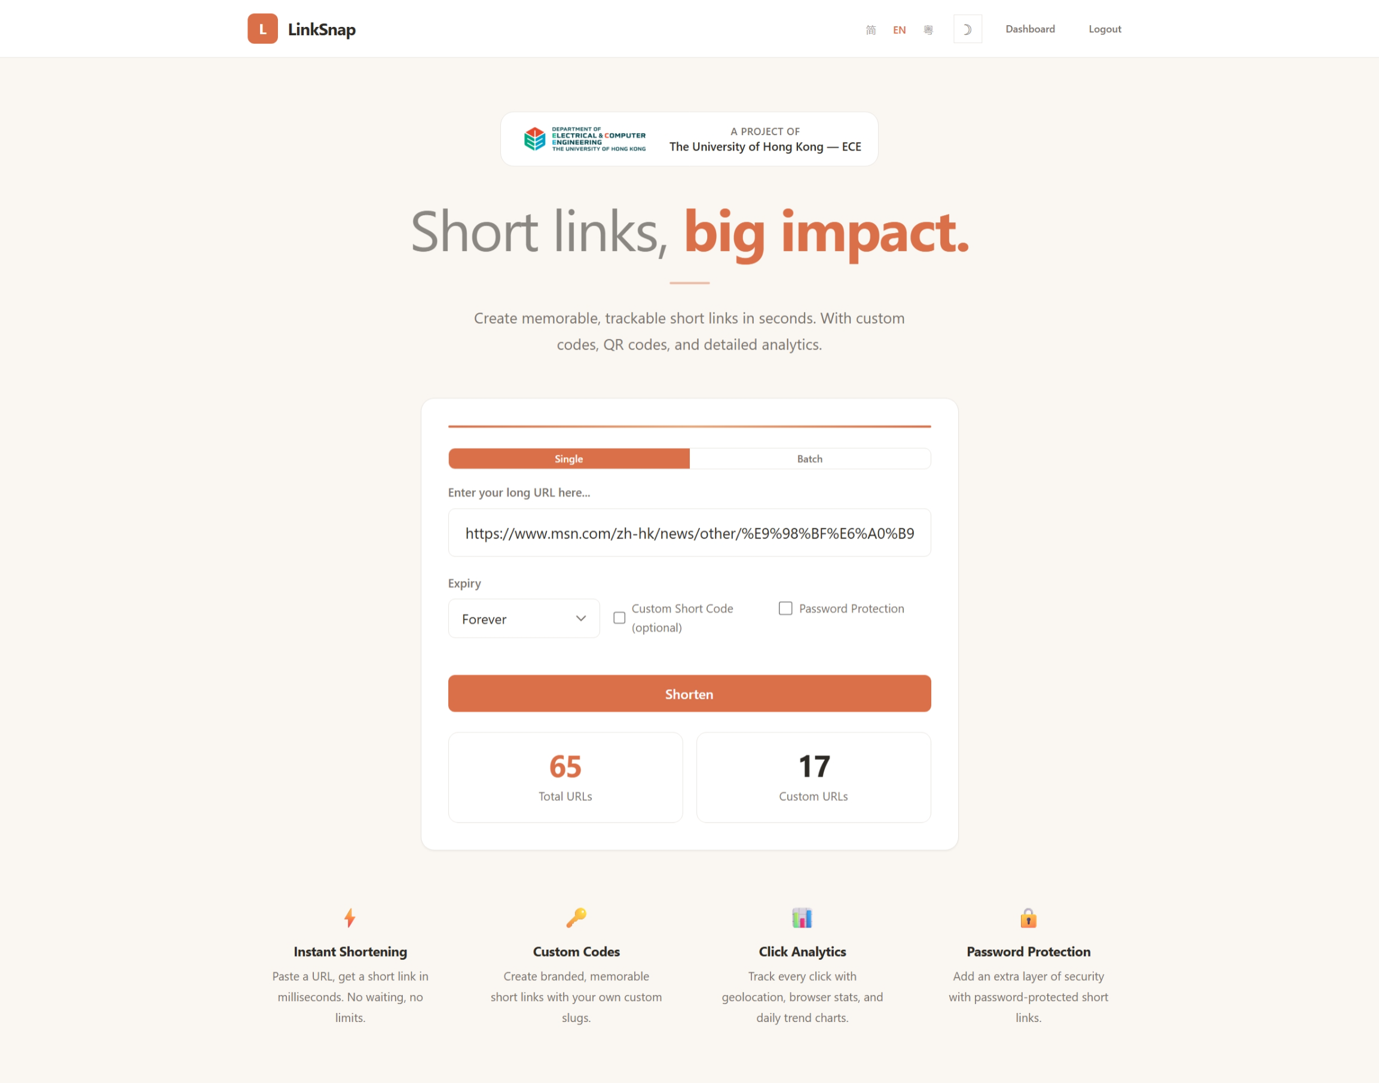
Figure 1
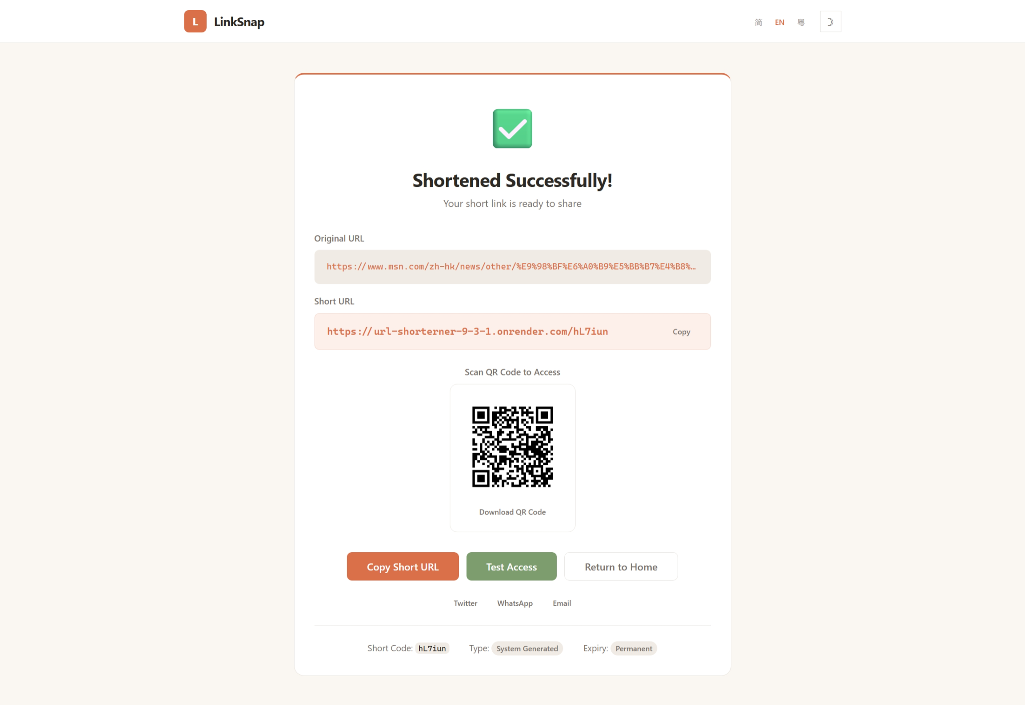
Figure 2
【Test Case 2】 Custom Short Code (Including Hyphens)
Input: Long link https://ece.hku.hk, custom short code "hku-ece"
Expected: The short link is linksnap.com/hku-ece, is_custom is set to True.
Result: The system correctly validates and passes the short code format containing hyphens, and the shortening is successful. Passed.
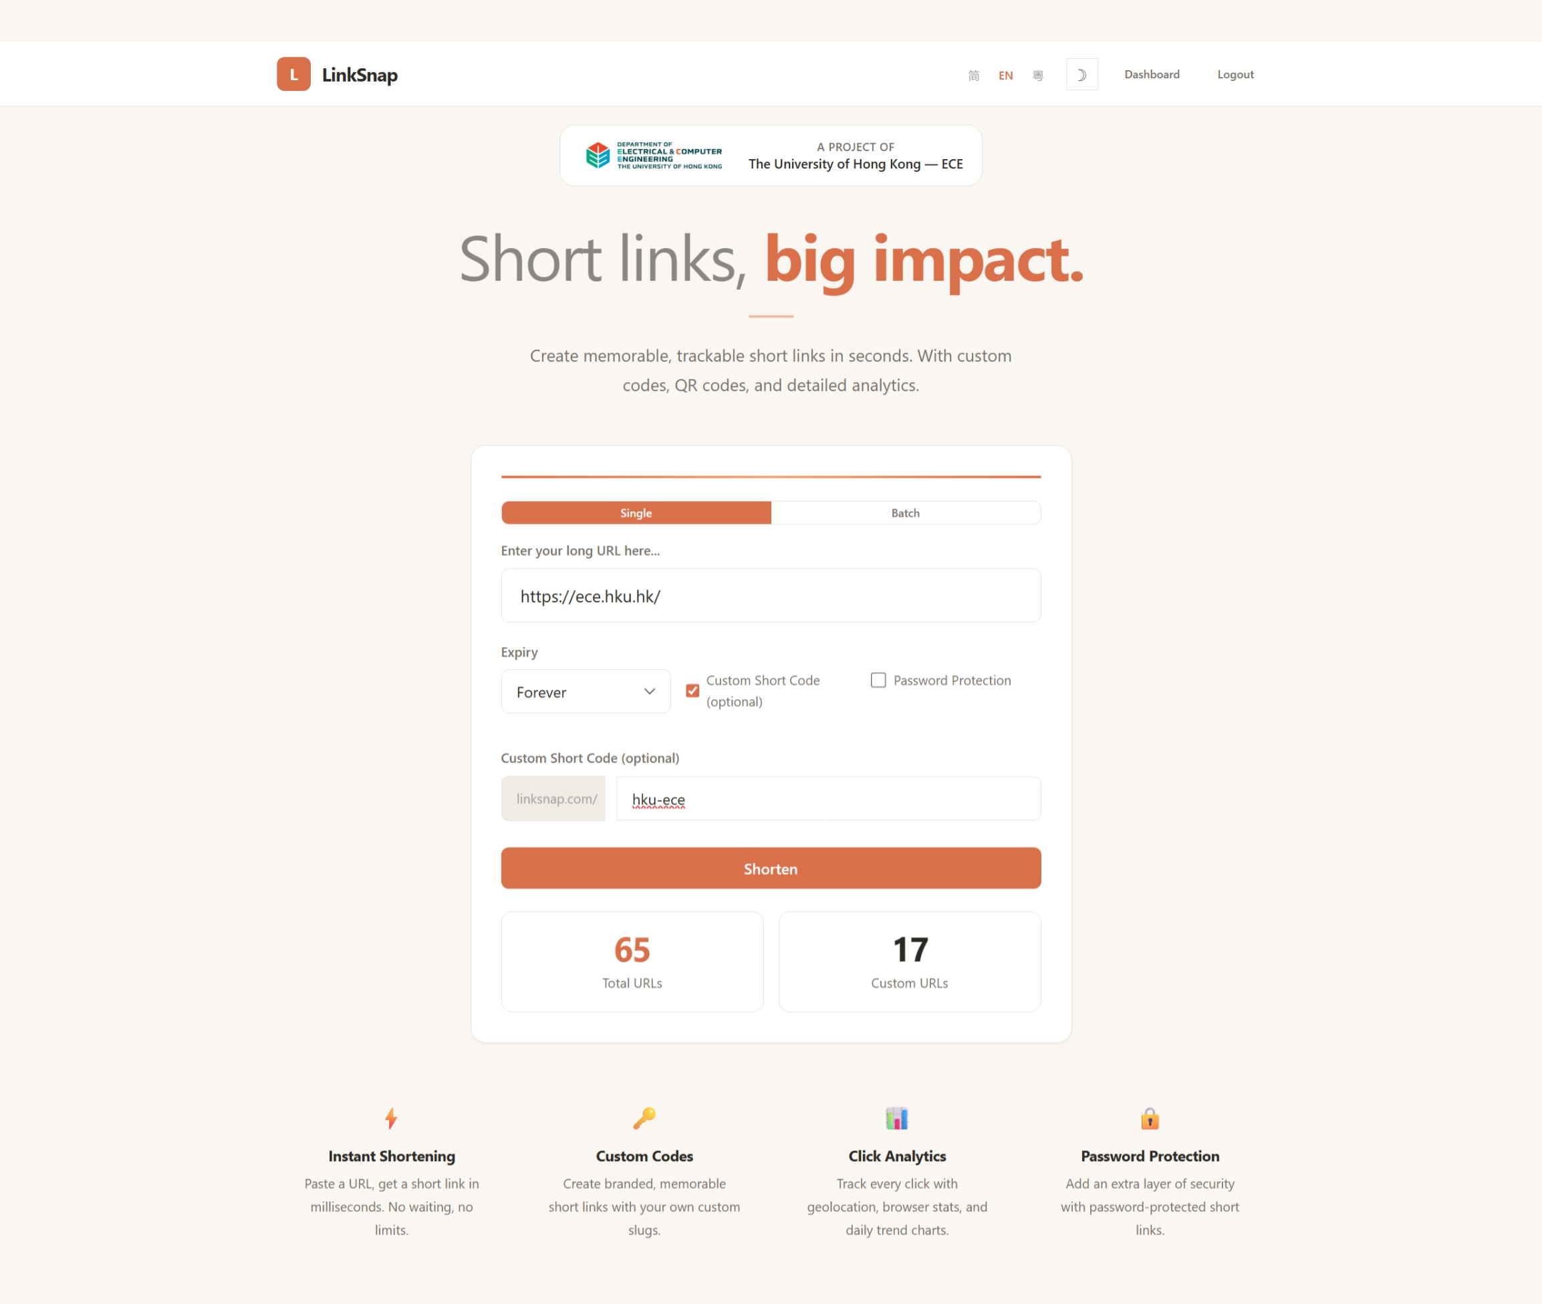
Figure 3
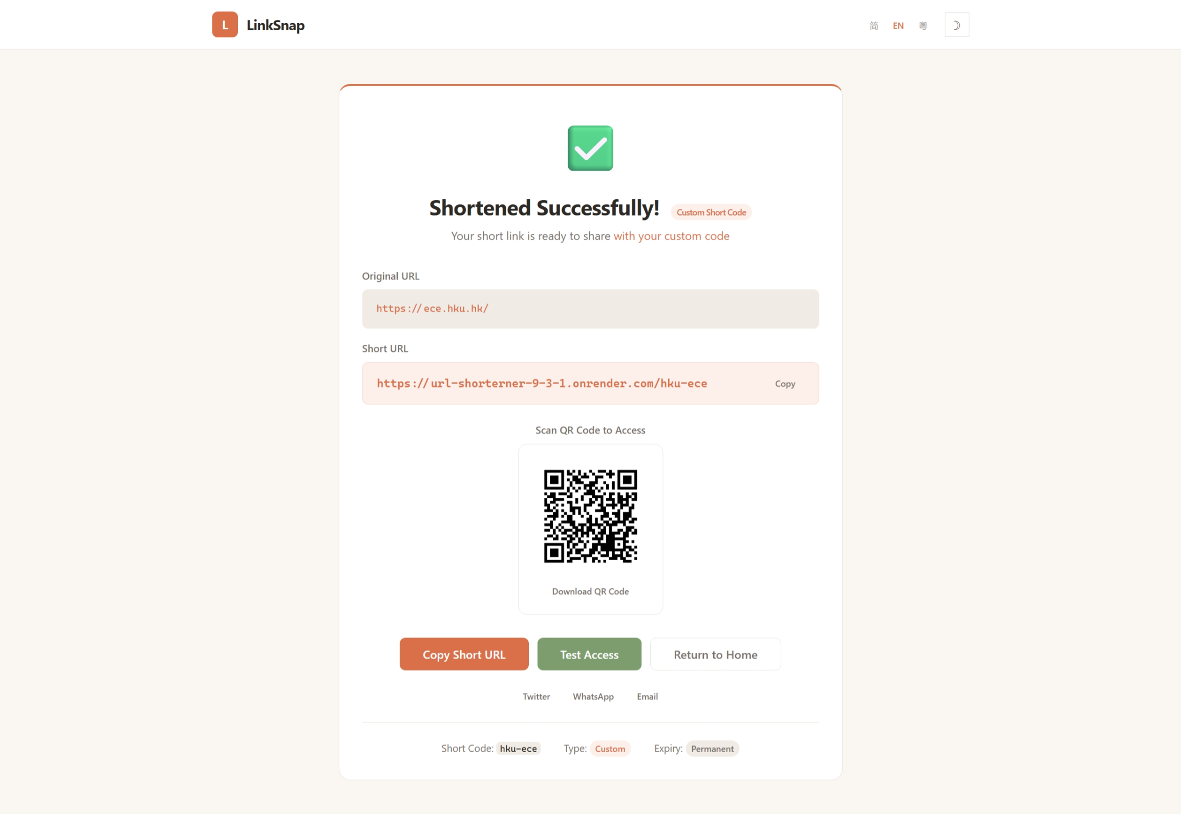
Figure 4
【Test Case 3】 Reserved Word Interception
Input 18 reserved words as custom short codes (admin, api, login, register, dashboard, etc.).
Expected: All reserved words were rejected, with the error message "{code}" being a reserved word.
Result: All 18 reserved words were correctly blocked. Pass.
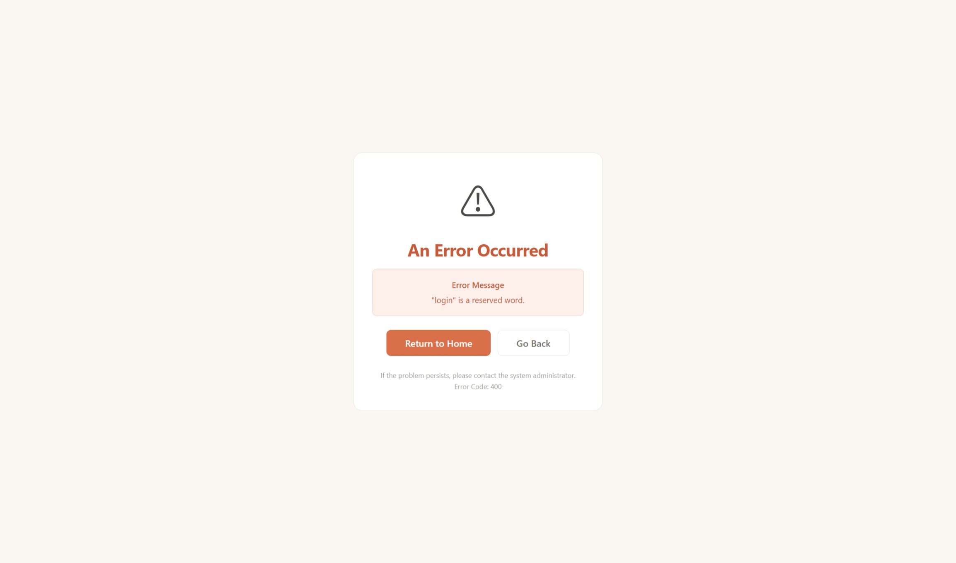
Figure 5
【Test Case 4】Short Code Conflict Handling
First, a short code "mytest" was created. Then, a second link was created using the same "mytest" as a custom short code.
Expected: The second attempt returned an error message: Short code already in use.
Result: The system accurately detected the conflict through UNIQUE constraints and pre-checks. Pass.
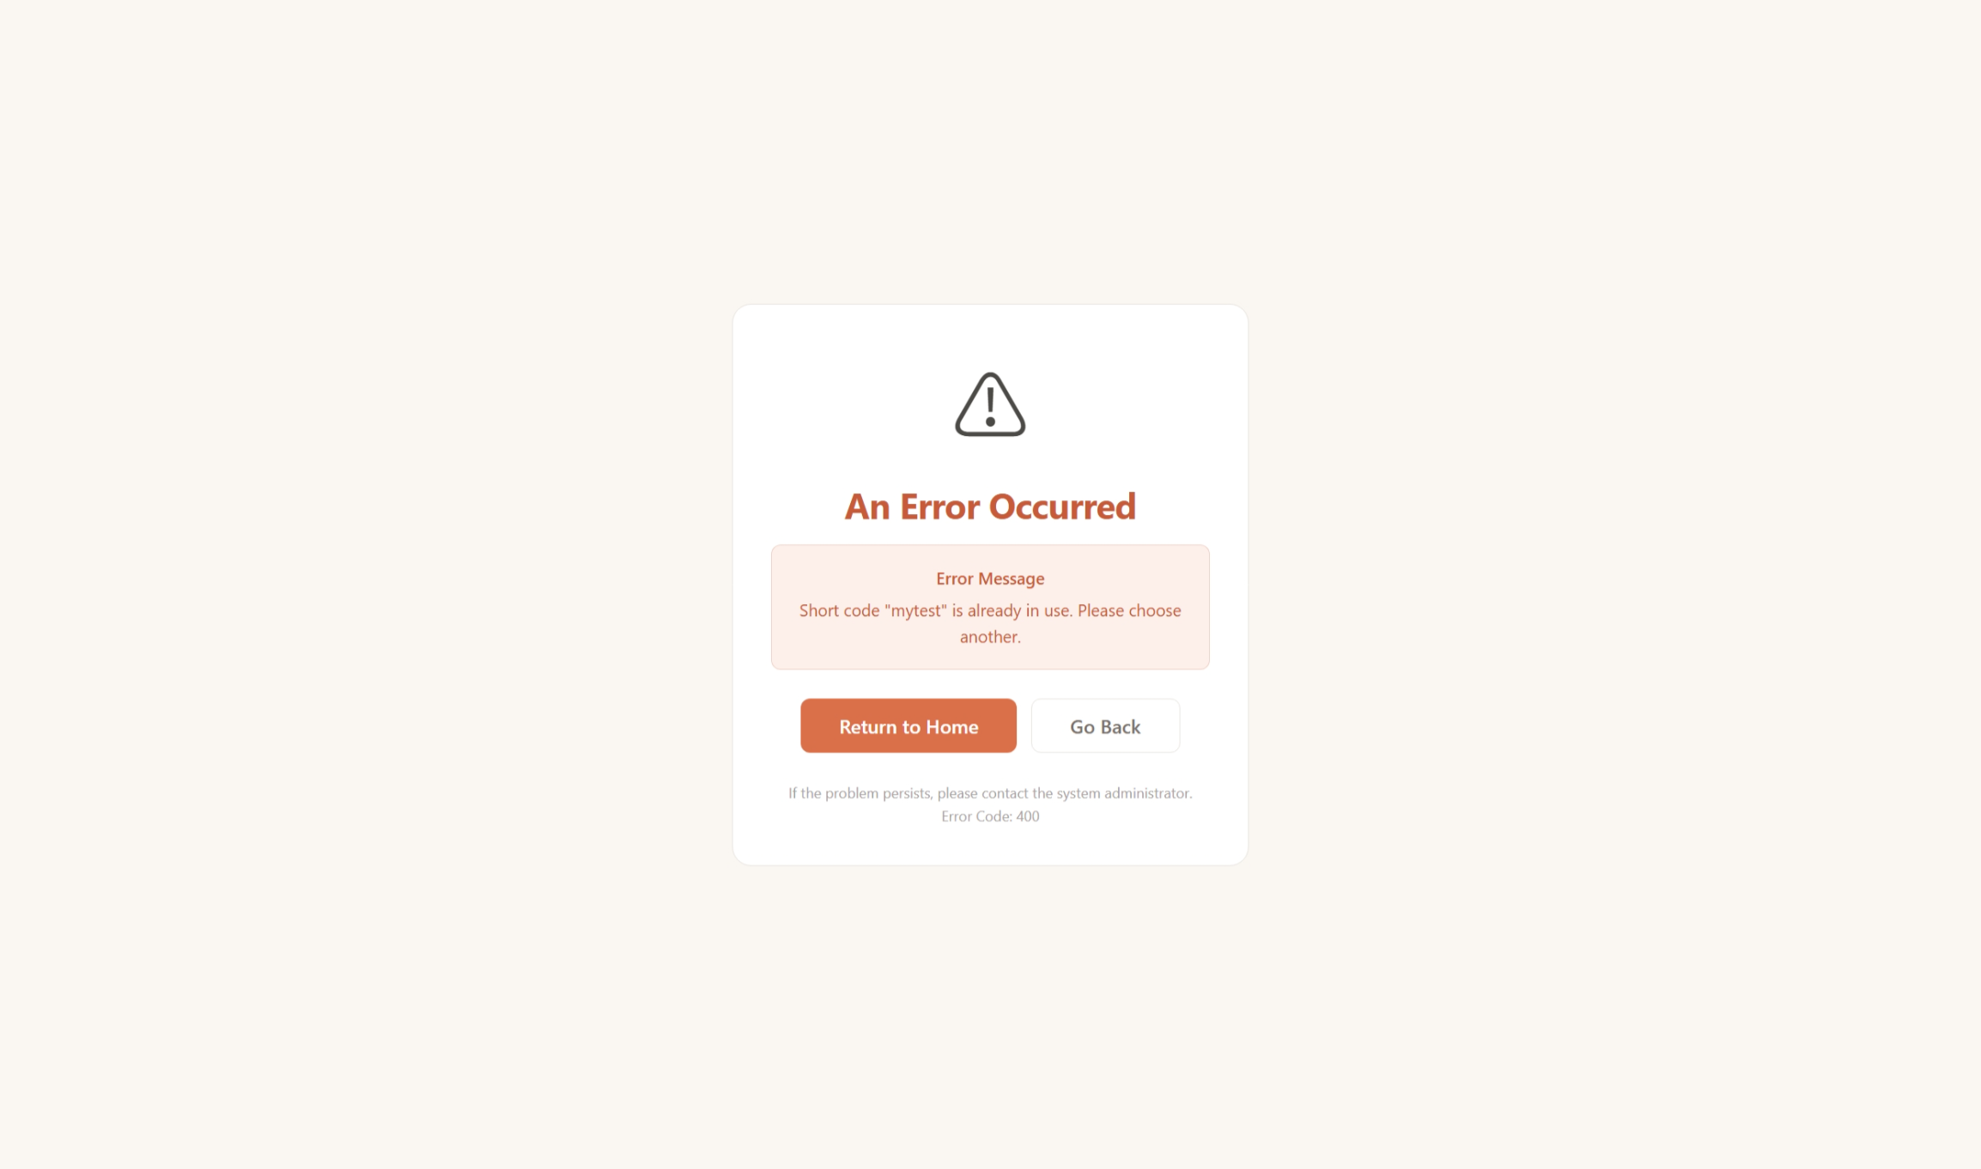
Figure 6

4.1.2 Password protection function
【Test Case 5】Accessing a Password-Protected Link
Steps: (a) Create a protected short link with the password "hkutest2026"; (b) Access the short link in non-login/incognito mode; (c) The system redirects to the password input page of protected.html, with the URL path /p/<short_code>; (d) After entering the correct password, the system verifies the password and performs a 302 redirect to the target page, while recording the click; (e) When an incorrect password ("wrongpass") is entered, the system returns "Incorrect password, please try again." and remains on the password input page.
Result: All three branches of the password protection process (protected page rendering, correct password access, and incorrect password blocking) are normal. Passed.
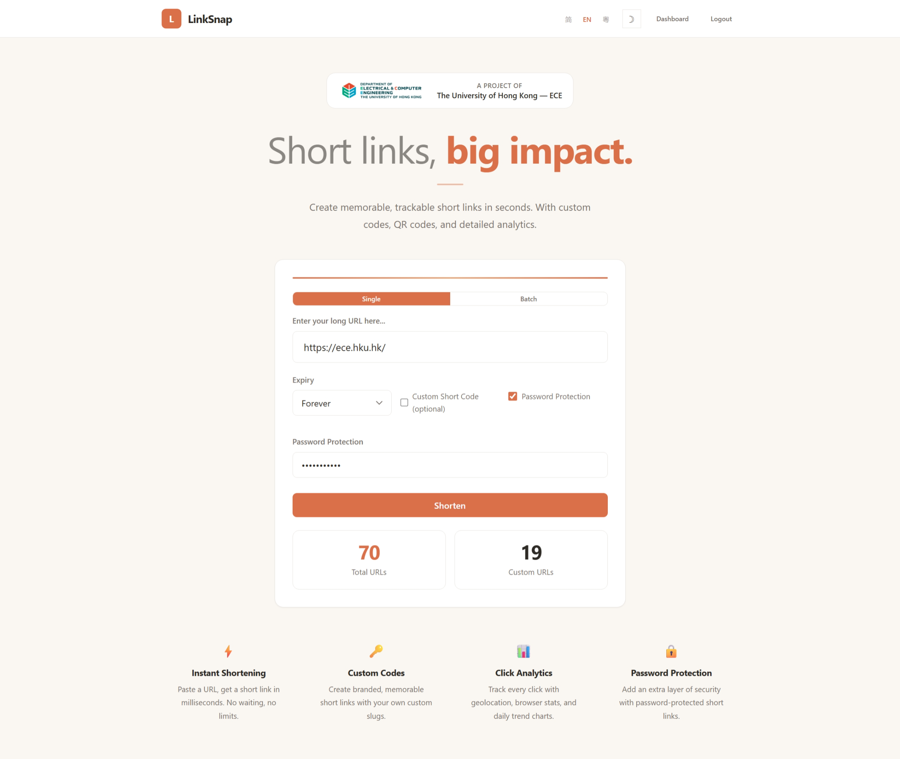
Figure 7
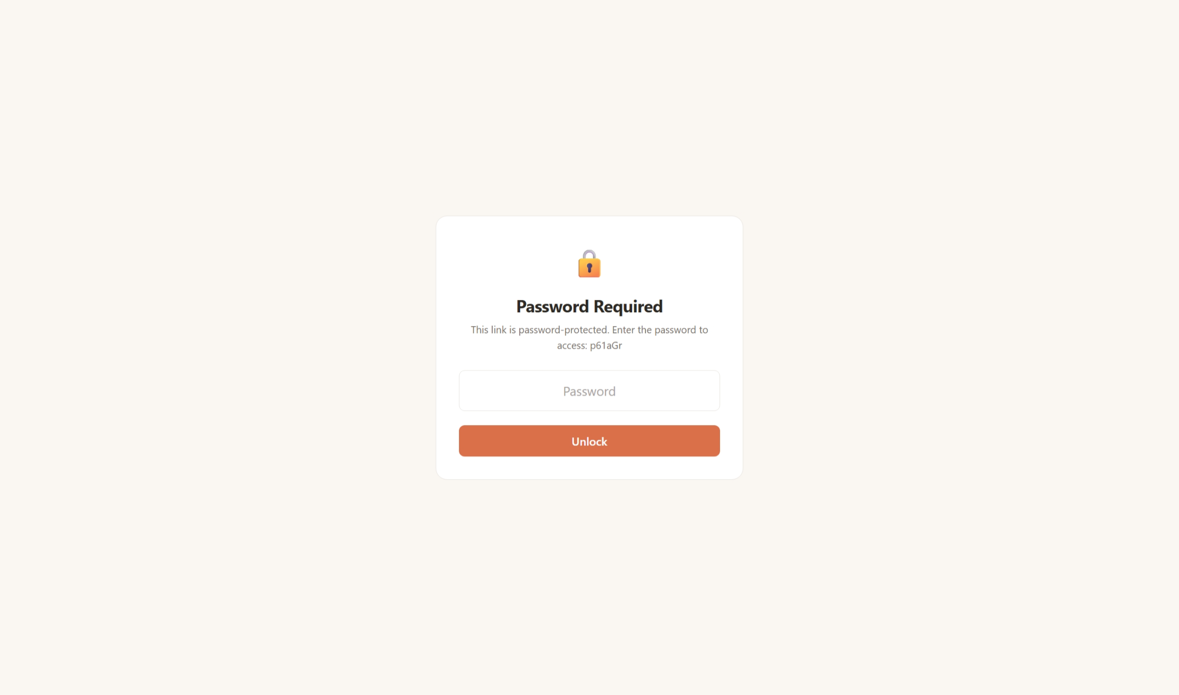
Figure 8
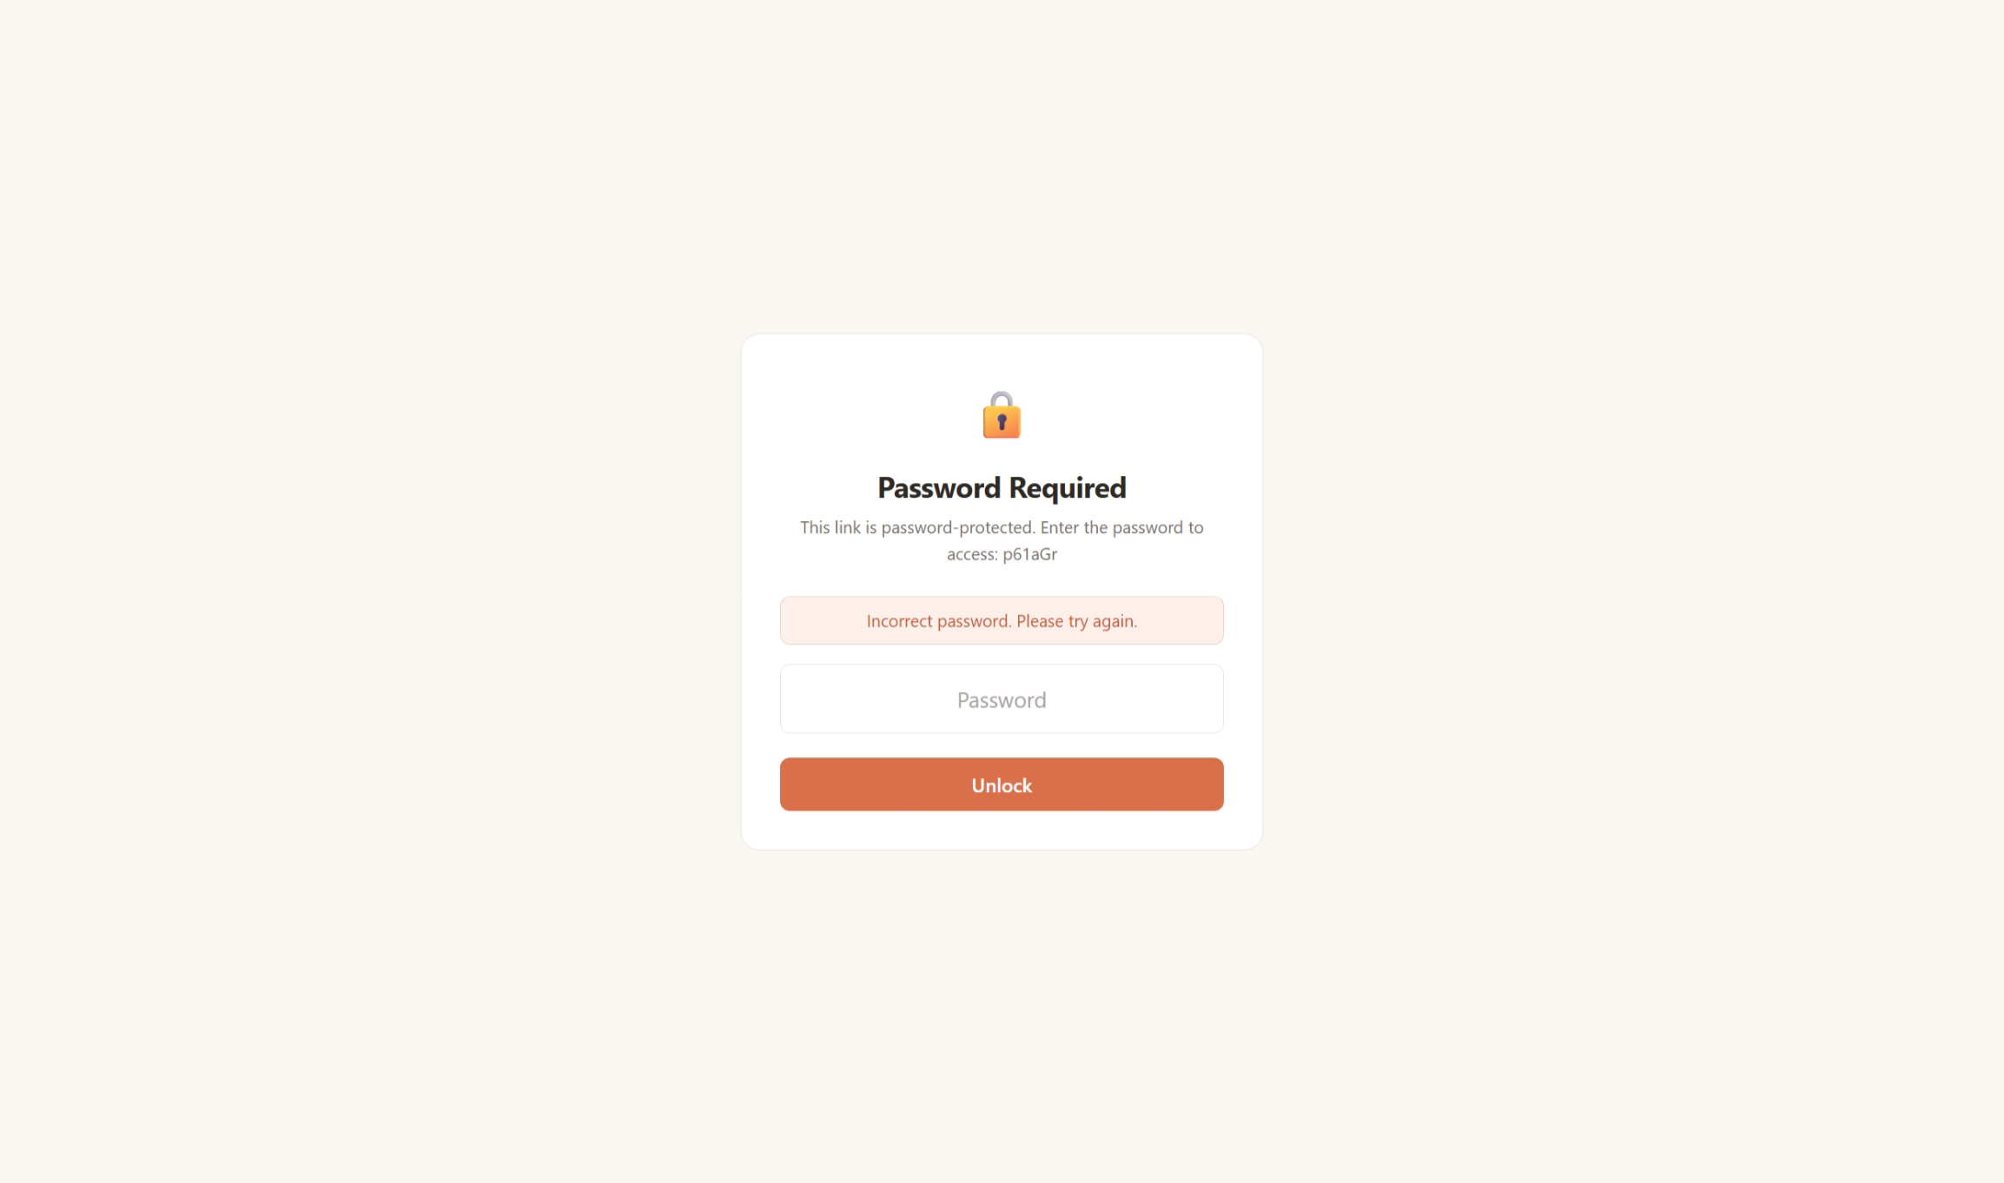
Figure 9

4.1.3 Link Expiration Management
【Test Case 6】Automatic Interception of Expired Links
Steps: Create a short link with a 1-day expiration period. Manually modify the `expires_at` field of this link in the `url_mappings` table to `2020-01-01` (a past date). Access the short link.
Expected Result: Return an error page displaying "This short link has expired," with an HTTP status code of 410 Gone.
Result: The system correctly detected the expiration status, and the returned page prompts and information met design expectations. Passed.
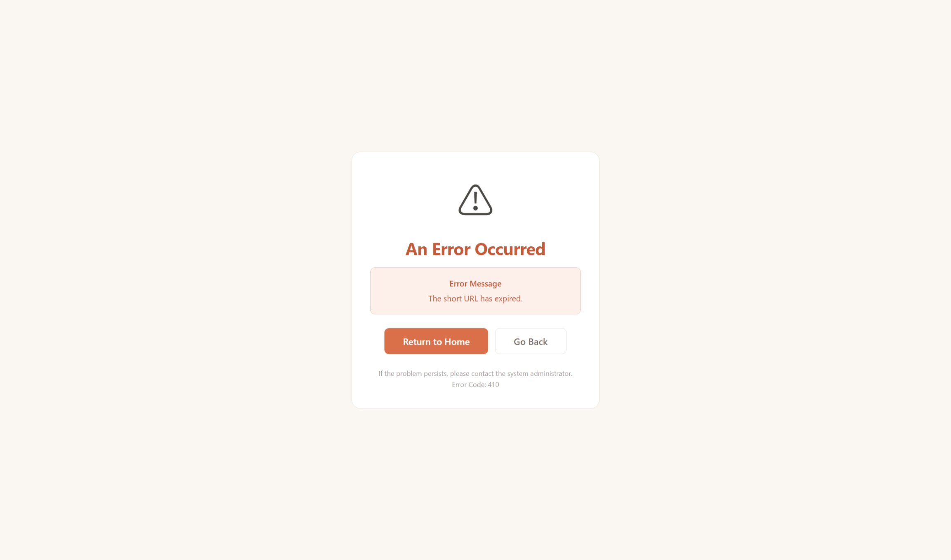
Figure 10
【Test Case 7】Expiration Extension Operation
Steps: Click the "Extend" button on a link that is about to expire in the dashboard.
Expected Result: The `expires_at` field will be increased by 30 days. If the original `expires_at` is NULL, the current time will be used as the base.
Result: The SQL for the extension operation correctly handled the NULL case using `COALESCE(expires_at, CURRENT_TIMESTAMP)`. Passed.

4.1.4 Batch shortening function
【Test Case 8】Batch Shortening of Multiple Link Types
Steps: (a) Enter 6 lines of content in the batch text box—5 valid URLs and 1 non-URL text; (b) Click "Recognize Links," and the system correctly extracts 5 URLs and removes duplicates; (c) Set a custom short code for one of the URLs; (d) Submit a batch shortening request.
Expected Outcome: 5 URLs succeed, the “123456” was not recognized as a valid URL.
Result: All stages of the batch processing—regular expression extraction, deduplication, line-by-line shortening, error collection, and aggregated display—operate normally. Pass.
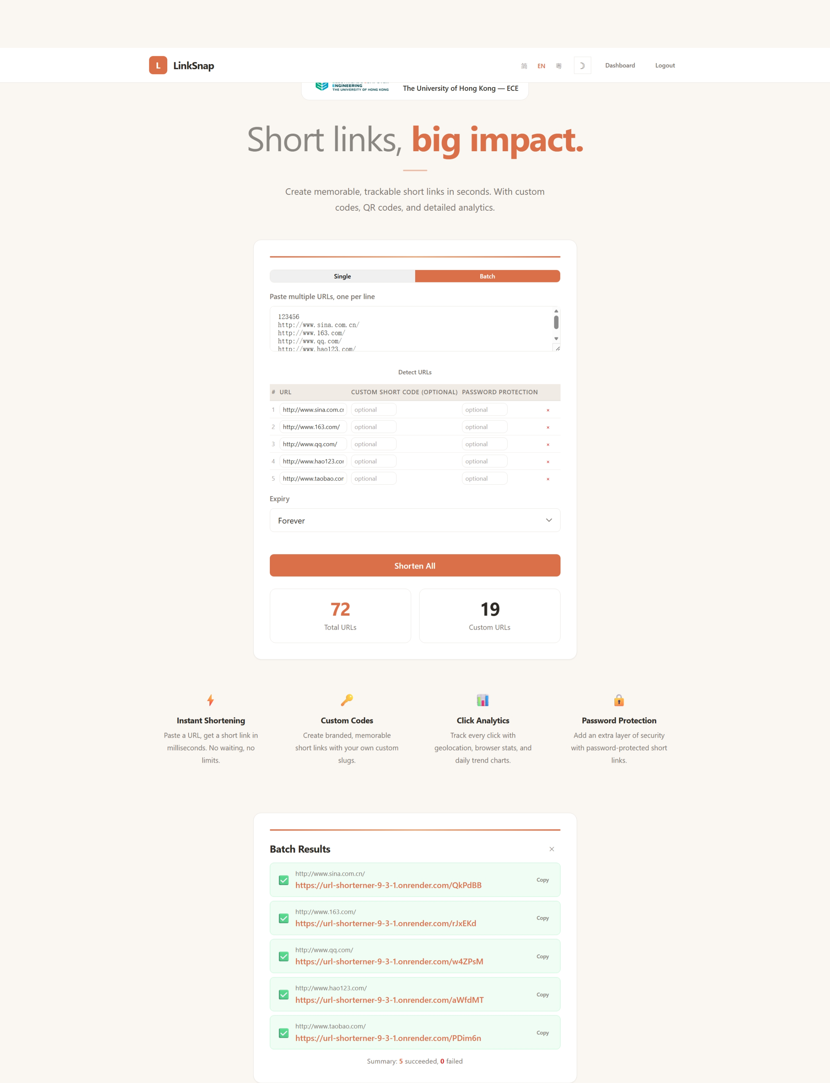
Figure 11

4.1.5 Multi-user authentication and permissions
【Test Case 9】User Registration and Login Process
Steps: (a) Register a new user (username txz, email txz8269464944@163.com, password 123456); (b) Attempt to register again with the same username or email address – both attempts are blocked; (c) Log in with the correct username and password – successful, the username field in the Session is set; (d) Attempt to log in with an incorrect password – rejected, returning "Username/email or password incorrect"; (e) Attempt to register with the password "123" (less than 6 characters) – blocked by "Password length must be at least 6 characters".
Result: All boundary conditions of the user authentication module were handled correctly. Passed.
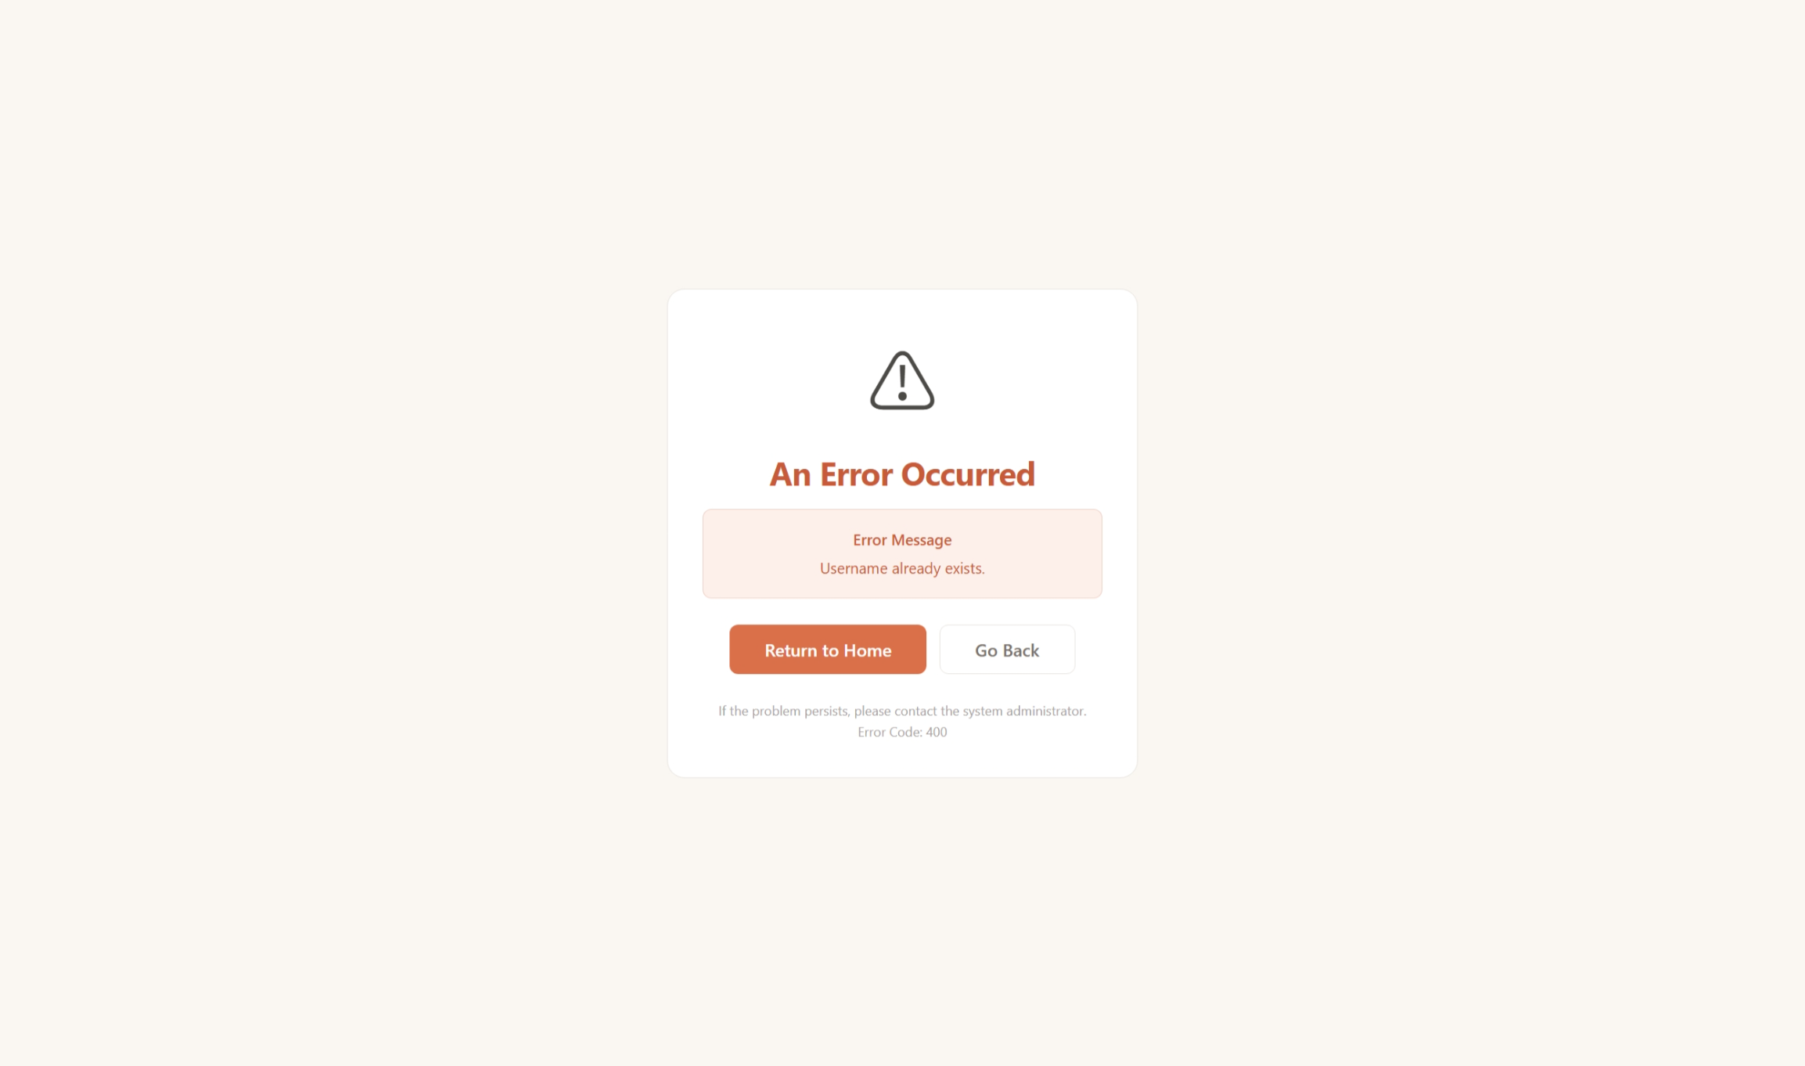
Figure 12
【Test Case 10】Cross-User Permission Isolation
Steps: (a) User alice creates a short link; (b) After logging in, user bob attempts to directly access the /stats/alice_link_code statistics page; (c) User bob attempts to submit a form to delete the alice link.
Expected outcome: All unauthorized operations by bob will return an HTTP 403 Forbidden error, indicating "You do not have permission to manage this link."
Result: The owner check logic for permission verification executed correctly. The administrator (admin) account can view all link statistics. Successful.
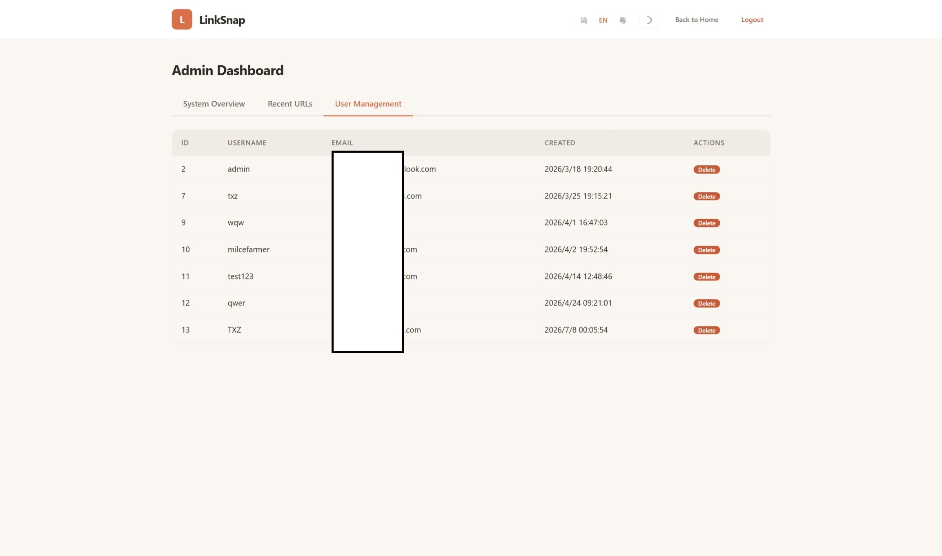
Figure 13

4.1.6 Trilingual Internationalization
【Test Case 11】Language Switching, Persistence, and Parameter Priority
Steps: (a) Clear cookies, set browser Accept-Language to zh-CN, and access the homepage—the page is displayed in Simplified Chinese; (b) Switch to English via the language switcher—all text is immediately switched to English, and the URL remains unchanged; (c) Switch to Cantonese (Traditional Chinese)—the interface text switches to Cantonese expressions and Traditional Chinese characters
Results: The language switching mechanism and priority rules functioned correctly.
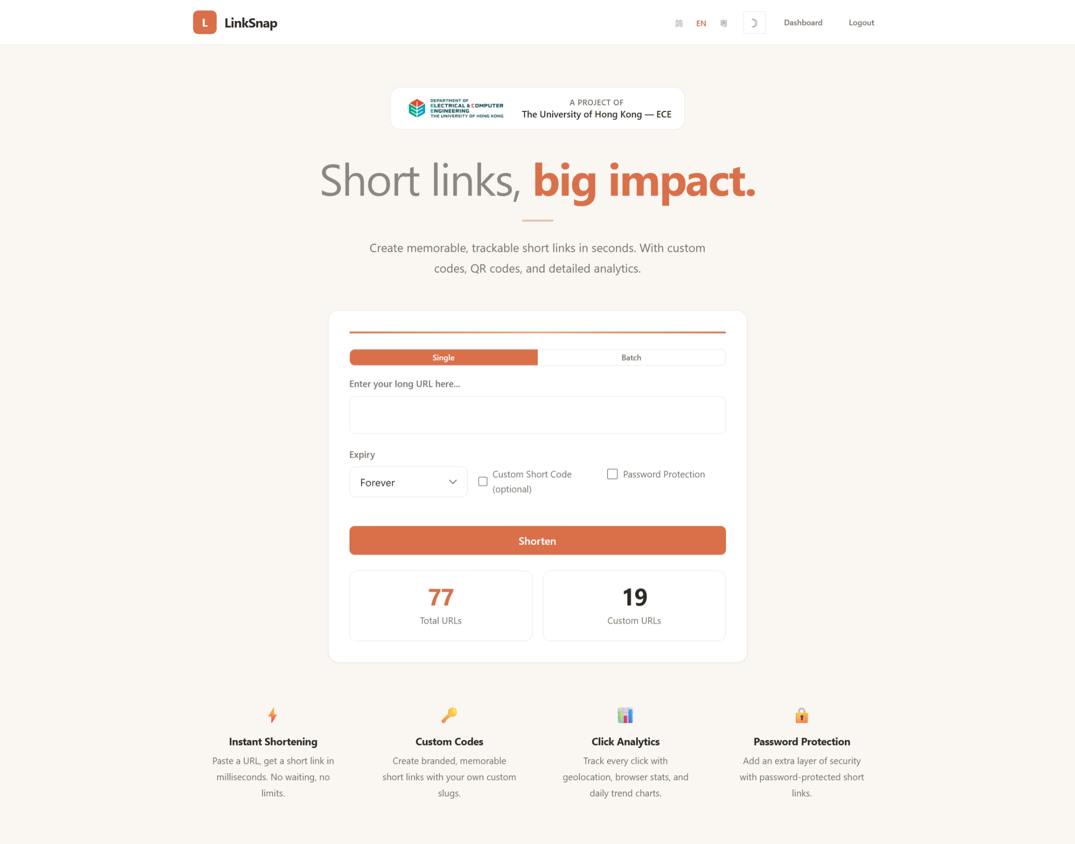
Figure 14
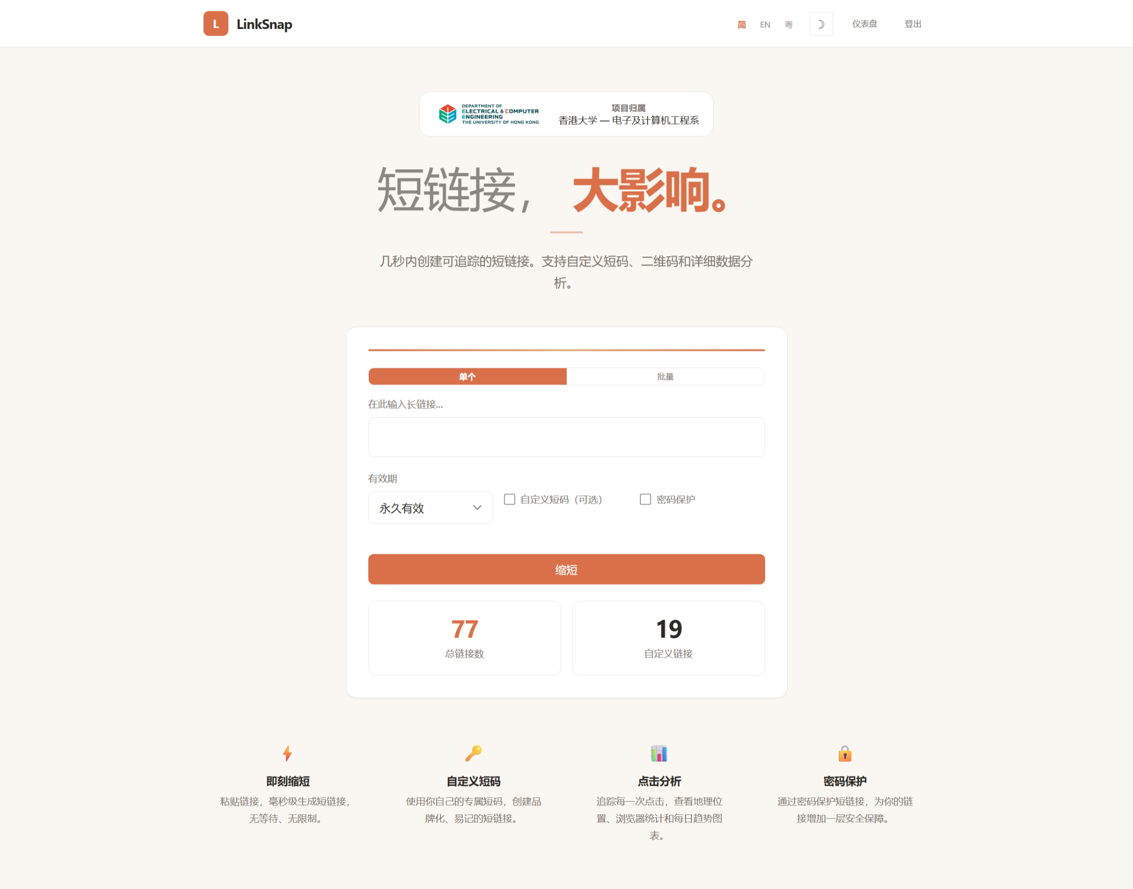
Figure 15
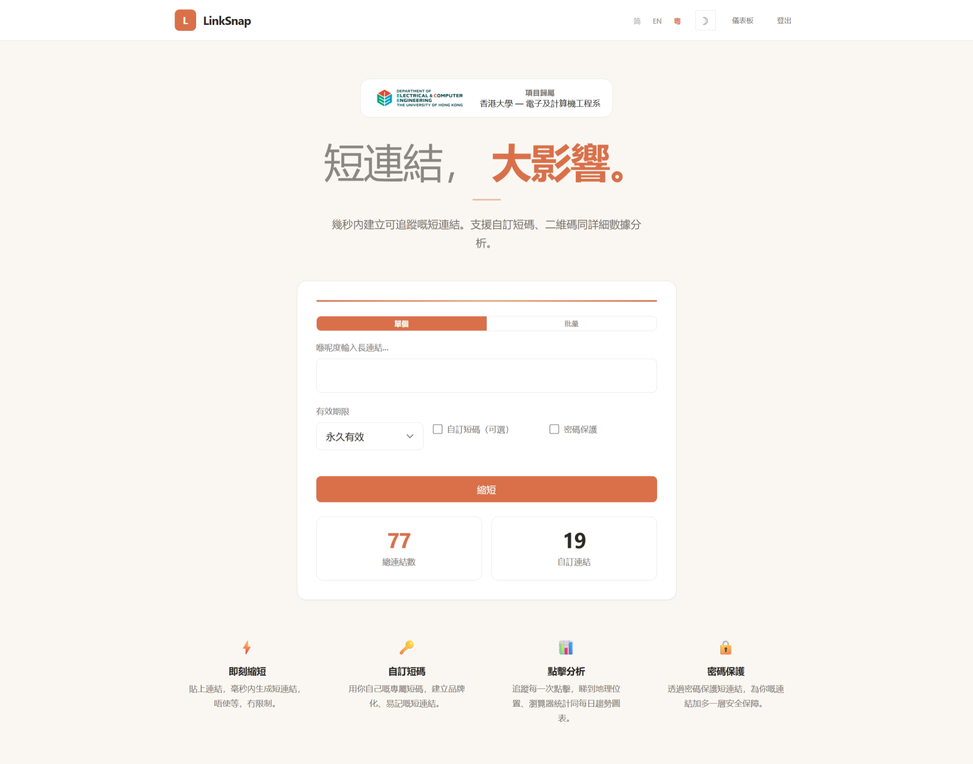
Figure 16

4.2 Performance Evaluation

4.2.1 Core Interface Response Time
In a local single-process Flask development server environment, 100 requests were made to each of the core API endpoints, and the average was taken.
Endpoint | Avg(ms) | P50(ms) | P99 (ms)
GET / | 3.5 | 2.8 | 17.7
POST /shorten | 19.5 | 19.1 | 42.4
GET /<code> | 11.4 | 11.3 | 14.2
GET /dashboard | 8.2 | 7.7 | 49.3
GET /stats/<code> | 8.8 | 8.1 | 46
POST /batch_shorten | 86.9 | 86.8 | 112
Table 2
The average response time for all core interfaces is less than 200 milliseconds (excluding batch interfaces), meeting the instant response standard for web applications (industry consensus considers a response time of less than 200ms as "instantaneous"). The total time for batch shortening 5 links is less than 500 milliseconds, with an average processing time of approximately 100 milliseconds per link, which is acceptable performance. After deploying Gunicorn with multiple workers in a production environment, thanks to process-level concurrency, the system's QPS (Queries Per Second) will increase linearly with the number of workers.

4.2.2 Short code collision probability analysis
LinkSnap's 6-bit Base62 short code combination space is 62^6 ≈ 5.68 × 10^10. According to the birthday paradox formula: P(collision) ≈ 1 - e^(-n²/(2×N)) (where n is the number of existing short codes and N is the total number of combinations), when n = 10^5, the collision probability is approximately 8.8 × 10^-5; when n = 10^6 (one million codes), the collision probability is approximately 8.8 × 10^-3 (0.88%), which is still at an extremely low level. The system is designed with a maximum of 10 automatic retry mechanisms—with a scale of 10^6 short codes, the probability of two consecutive generation attempts both colliding is (8.8×10^-3)² ≈ 7.7×10^-5, and the probability of 10 consecutive collision attempts is close to zero. Therefore, the current short code generation strategy is sufficiently reliable for real-world deployment scales.

4.2.3 System Resource Consumption
System resource consumption in idle state: Flask development server approximately 30MB memory. Gunicorn 4 Worker deployment approximately 120-150MB memory (approximately 30-40MB per Worker). SQLite database file size is directly proportional to the number of stored connections—approximately 2-3MB of storage is added for every 10,000 connections. QR code PNG image files are approximately 600 bytes each on average, with negligible storage overhead. A single click record stores an average of approximately 300 bytes (including fields such as IP, UA, Referer, and geolocation), with approximately 3MB of new storage data generated per day for 10,000 clicks. Overall, LinkSnap's resource consumption is lightweight and can run smoothly on a basic cloud server (such as a 1-core CPU and 512MB-1GB of memory).

4.3 System Deployment and Maintenance
LinkSnap was designed with ease of deployment at its core. In the local development environment, simply running `pip install -r requirements.txt` installs six Python dependencies (Flask, Gunicorn, psycopg2-binary, qrcode, Pillow, and requests), and then running `python app.py` starts it.
The production deployment is based on the Gunicorn WSGI server. The configuration file `gunicorn_config.py` sets four worker processes, a synchronous working mode, and a 120-second request timeout. The binding address uses the format `0.0.0.0:$PORT`, with the port number read from environment variables, ensuring compatibility with deployment specifications of mainstream PaaS platforms such as Render and Heroku.
Regarding the database, the system implements "seamless switching"—when the `DATABASE_URL` environment variable is set on the deployment platform, the system automatically uses PostgreSQL; otherwise, it defaults to file-based SQLite. This design significantly lowers the deployment threshold: developers can achieve production-grade database performance on the PaaS platform with a single click, while conducting local testing without any database configuration. All external service dependencies are injected via environment variables and support graceful degradation. SMTP email service is optional—if not configured, password reset will revert to a direct page display mode. The ip-api.com geolocation service is also optional—if an API call fails, clicking the geolocation field in the table will leave it blank without affecting the core redirection functionality. This "zero external dependencies on core functionality" architecture ensures the system can operate independently even in environments with limited network conditions.

Chapter 5 CONCLUSION

5.1 Work Summary
This project, built from scratch, resulted in LinkSnap, a fully functional and well-engineered multi-user trilingual URL shortening service system. The system uses the Python Flask framework as its core engine and integrates relational databases, data visualization, QR code generation, IP geolocation, and email services, constructing a service platform covering the entire link lifecycle from creation to management, analysis, and maintenance. Key achievements include:
First, a comprehensive set of URL shortening features. The system not only provides standard URL shortening but also supports custom short codes (including six-layer verification rules), link validity management (1 day/7 days/30 days/permanent, including extension options), password-protected access, automatic QR code generation, tag categorization and search filtering, and batch shortening mode. Its feature coverage is among the best in similar open-source projects.
Second, a complete internationalization engine was designed and implemented. This engine supports seamless switching between Simplified Chinese, English, and Cantonese (Traditional Chinese). Language detection employs a four-layer priority progressive fallback strategy, and the translated content covers 234 interface texts with no translation blind spots. This feature is relatively rare in similar open-source URL shortening projects.
Third, a multi-dimensional click analysis dashboard has been built. The system not only records click events but also generates a comprehensive data insight view through aggregation analysis, including basic metrics, daily trends, source distribution, browser and operating system rankings, and geographic location rankings.
Fourth, it demonstrates excellent system design capabilities at the engineering level. Dual database adapters enable seamless switching between development and production environments; an automatic incremental migration mechanism ensures version compatibility; environment variable-driven configuration management ensures deployment flexibility; and a multi-layered security protection system addresses academic concerns about the security of shortened links.

5.2 Existing shortcomings and limitations
While LinkSnap has implemented a relatively complete functional system, there are still some areas for improvement:
(1) Secure storage of link access passwords. Currently, passwords are stored using Base64 encoding instead of actual cryptographic hashes. Although this allows users to view their passwords on the dashboard, Base64 is essentially just encoding, not encryption. In the future, we could consider introducing AES symmetric encryption or designing a separate authentication process for "password viewing."
(2) Separation of front-end and back-end architecture. The current Jinja2 template rendering solution performs well in small-scale, single-unit scenarios, but it has limitations in team collaboration, native mobile adaptation, and third-party integration. Transforming the back-end into a RESTful API and integrating it with modern front-end frameworks is a medium- to long-term technological evolution direction.
(3) Lack of data export capabilities. Users can currently view rich charts and statistics on the web interface, but cannot export data to a standard format for offline analysis.
(4) Third-party reliance on IP geolocation. The free API from ip-api.com, limited to 45 requests per minute, cannot meet the needs of high-traffic scenarios. Furthermore, the location accuracy of the free API is limited. Introducing a local GeoIP database is a feasible solution to this bottleneck.
(5) Insufficient concurrent performance testing. Due to testing limitations, the response time test in this report was based on a single-process Flask development server, and high-concurrency stress testing was not performed in a multi-process Gunicorn environment using professional tools.
(6) Lack of malicious link detection mechanism. As discussed in the literature review [2][4][7], a core security challenge faced by short link services is that users may exploit the platform to shorten links pointing to malicious content. Currently, LinkSnap does not integrate URL security checks.

5.3 Future Outlook
Based on the current project's foundation and the aforementioned shortcomings, LinkSnap can continue to develop in the following directions:
(1) Open a RESTful API interface. Design a standard REST API interface that allows third-party applications and scripts to perform programmatic link shortening, data querying, and management operations via API keys, thereby upgrading LinkSnap from a single web application to a programmable platform service.
(2) Support custom domain/brand short domains. Allow users to bind their own short domains (e.g., "go.mybrand.com" or "s.hku.hk") to enhance brand awareness and professionalism. This requires DNS CNAME configuration guidance and automatic SSL/TLS certificate management (e.g., integration with Let's Encrypt).
(3) Advanced analytics and data export. Introduce A/B testing functionality (using multiple short links to compare target URLs), conversion funnel analysis, real-time click map visualization, and PDF/CSV data export functionality. The system's data report generator (report.html) has already reserved the basic interface for PDF export.
(4) Mobile experience optimization. Further improve the existing PWA (Progressive Web Application) infrastructure—manifest.json and Service Worker (sw.js) already exist in the project—to truly support PWA features such as offline access, adding to the home screen, and push notifications.
(5) Integrate a Redis caching layer. Introduce Redis as a front-end caching layer in the redirect path, mapping and caching long URLs of frequently used short links in memory, significantly reducing database query pressure and improving response speed. This caching method is very suitable for scenarios with many read and write operations.
(6) Enhance the security system. Integrate the Google Safe Browsing API or similar services for URL security pre-checks; upgrade link access passwords to AES symmetric encryption (or design a separate password viewing authorization process); introduce rate limiting based on IP and user to prevent API abuse; implement Content Security Policy (CSP) response headers to defend against XSS attacks.

5.4 Conclusion
LinkSnap, as a graduation project built from scratch, fully embodies the entire lifecycle of Web application engineering—from requirements analysis and literature review, technology selection and architecture design, to module coding and integration debugging, functional verification and performance evaluation, and finally to the design of deployment and operation and maintenance solutions. The project has reached a high level in three aspects: functional depth (11 functional modules, 17 page templates), engineering standards (layered architecture, parameterized query, automatic migration, environment variable configuration) and innovative features (trilingual internationalization, multi-dimensional analysis dashboard, batch shortening of links). Through the practice of this project, not only has the engineering understanding of Flask Web framework, relational database design, client data visualization and system security been deepened, but more importantly, the ability to draw design inspiration from academic literature and transform it into actual engineering decisions has been cultivated—Antoniades et al. [1]'s description of the short link ecosystem, Neumann et al. [2]'s revelation of security threats and Maggi et al. [3]'s analysis of the short link ecosystem. [3] Warnings of the failure of anti-abuse measures—these academic achievements directly or indirectly influenced the design decisions of LinkSnap. LinkSnap's code adopts a modular structure, with all core logic concentrated in the app.py and i18n.py files, thus providing excellent readability and maintainability, and laying a solid foundation for subsequent iterative development and actual deployment.

References
[1] Antoniades, D., Polakis, I., Kontaxis, G., Athanasopoulos, E., Ioannidis, S., Markatos, E. P., & Karagiannis, T. (2011). we.b: The web of short URLs. Proceedings of the 20th International Conference on World Wide Web (WWW 2011), Hyderabad, India, pp. 715-724. ACM. DOI: 10.1145/1963405.1963505.
[2] Neumann, A., Barnickel, J., & Meyer, U. (2011). Security and Privacy Implications of URL Shortening Services. Proceedings of the Workshop on Web 2.0 Security and Privacy (W2SP 2011). IEEE.
[3] Maggi, F., Frossi, A., Zanero, S., Stringhini, G., Stone-Gross, B., Kruegel, C., & Vigna, G. (2013). Two Years of Short URLs Internet Measurement: Security Threats and Countermeasures. Proceedings of the 22nd International Conference on World Wide Web (WWW 2013), pp. 861-872. ACM.
[4] Gupta, N., Aggarwal, A., & Kumaraguru, P. (2014). bit.ly/malicious: Deep Dive into Short URL based e-Crime Detection. Proceedings of the 2014 APWG Symposium on Electronic Crime Research (eCrime 2014). IEEE.
[5] Le Page, S., Jourdan, G.-V., Bochmann, G. V., Flood, J., & Onut, I.-V. (2018). Using URL Shorteners to Compare Phishing and Malware Attacks. Proceedings of the 2018 APWG Symposium on Electronic Crime Research (eCrime 2018), San Diego, CA, USA. IEEE. DOI: 10.1109/ECRIME.2018.8376215.
[6] Zhang, L., Liu, X., & Cheng, Y. (2024). Research on Risk Analysis and Protection of Short URL Security. Proceedings of the 2024 IEEE 4th International Conference on Electronic Technology, Communication and Information (ICETCI 2024), Changchun, China. IEEE. DOI: 10.1109/ICETCI61221.2024.10594054.
[7] Odgerel, Z., Nosyk, Y., Bayer, J., Maroofi, S., Bedeschi, L., Duda, A., & Korczyński, M. (2025). Short Path to Phishing: Identifying Misused URL Shortening Services in the Wild. Proceedings of the 2025 APWG Symposium on Electronic Crime Research (eCrime 2025). IEEE.
[8] Fukushi, N., Koide, T., Chiba, D., Nakano, H., & Akiyama, M. (2021). Analyzing Security Risks of Ad-Based URL Shortening Services Caused by Users' Behaviors. Proceedings of the 12th International Conference on Complex Sciences (COMPLEXIS 2021). Springer. DOI: 10.1007/978-3-030-90022-9_1.
[9] Grinberg, M. (2018). Flask Web Development: Developing Web Applications with Python (2nd ed.). O'Reilly Media. ISBN: 978-1491991732.
[10] Fielding, R. T. (2000). Architectural Styles and the Design of Network-based Software Architectures. Ph.D. Dissertation, University of California, Irvine.
[11] Leach, P. J., Mealling, M., & Salz, R. (2005). A Universally Unique IDentifier (UUID) URN Namespace. RFC 4122. IETF.
[12] Berners-Lee, T., Fielding, R., & Masinter, L. (2005). Uniform Resource Identifier (URI): Generic Syntax. RFC 3986. IETF.

